**INDEX**

|  |  |  |
| --- | --- | --- |
| **SR.NO** | **CONTENTS** | **page no.** |
| **1** | TITLE OF THE PROJECT |  |
| **2** | PROJECT APPROVAL  CERTIFICATE |  |
| **3** | ACKNOWLEDGMENT |  |
| **4** | CERTIFICATE OF ORIGINALITY |  |
| **5** | INTRODUCTION OF PROJECT |  |
| **6** | OBJECTIVE |  |
| **7** | PROJECT CATEOGRY |  |
| **8** | NO. OF MODULES |  |
| **9** | DATA FLOW DIAGRAM |  |
| **10** | PERT CHART |  |
| **11** | GANTT CHART |  |
| **12** | ER DIAGRAM |  |
| **13** | TOOLS PLATFORM USED |  |
| **14** | ABOUT FRONT END |  |
| **15** | ABOUT BACK END |  |
| **16** | SCREEN SHOT LAYOUT |  |
| **17** | REPORT |  |
| **18** | CODING |  |
| **19** | FEASIBILITY STUDY |  |
| **20** | TESTING |  |
| **21** | FUTURE SCOPE AND  ENHANCEMENT |  |
| **22** | LIMATATION |  |
| **23** | BIBLIOGRAPHY |  |

**INTRODUCTION**

**Crime Solution Sys**tem is a system used to report crimes. This project will be done using php as front end, and My SQL as back end. It can used to report crime. This project is mainly useful for police stations. This system will help to manage all the activities in a police station using computers. Currently all the works are done manually, by computerizing all the activities inside a police station can be managed easily and effectively.

The modules involved in this project are:

* Login for user and admin
* Complaint registration
* View complaint status
* Criminal register management
* FIR Management
* Manage list about most wanted criminals

# LOGIN

This includes Administrator and User login. There will be a username and password to login into the system to use all the facilities.

1. **COMPLAINT REGISTRATION**

This module helps to register the details about the crime. This is done by entering some details, such as incident details, Victim details, crime details etc

**3. View complaint status**

This module allows us to view the status of the complaint that you have registered earlier.

**4. CRIMINAL register management**

Here we can have the facility to view the details of the criminals. The administrator can add new criminal’s details and save it in a database. This can be done by entering details such as criminal number, age, occupation, type of crime etc.

**5. FIR ManAgement**

This module allows viewing the First Information Report of all the crimes that took place at recent year

**6. Manage the list of most wanted criminals**

This is an additional feature added to this Software, which helps us to make a quick search about the most wanted criminals. This helps to always keep track of and identify a person quickly, who is a most wanted criminal.

**Proposed System**

The aim of proposed system is to develop a system of improved facilities. The proposed system can overcome all the limitations of the existing system. The system provides proper security and reduces the manual work.

* Security of data.
* Ensure data accuracy’s.
* Proper control of the higher officials.
* Minimize manual data entry.
* Minimum time needed for the various processing.
* Greater efficiency.
* Better service.
* User friendliness and interactive.
* Minimum time required.

**Existing System**

* Lack of security of data.
* More man power.
* Time consuming.
* Consumes large volume of pare work.
* Needs manual calculations.
* No direct role for the higher officials.

**OBJECTIVES**

This project of **“Online -Crime Solution”**of gives us the complete information about the Crime. We can enter the record criminals and retrieve the details of criminals available in the record. We can do fir and maintain their records. In this project we can maintain the senior citizen module, missing person module.

This project also enables the user to search for any information that the user wants. The user can use this project find out details or status of their F.I.R., TOP MOST CRIMINAL, Contact Details, and About Ranchi Police etc.

This project also enables the   senior citizens to register their information to any police station .This block contain registration-id, no. of servant at house, house-no., occupation, married or unmarried, tenant block. Also contain traffic and licensing unit and security of women & children unit.

Throughout the project the focus has been on presenting information and comments in an easy and intelligible manner. The project is very useful for those who want to know about Online Crime Management System.

**PROJECT CATEGORY**

The Category of this project is RDBMS (Relational Database Management System).Nowadays nearly all organization is using LANs for their internal transactions. And for These types of organizations RDBMS can be the best way to ease out the daily work for which one has to consistently move from one module to the other inside the organizations.

As a software developer or as a programmer, we are expected to design and developed any program that works correctly, efficiently and the time is easy to be used by every person, who may or may not be well versed with computer and its capabilities.

The Project is based on the Online Crime Solution System, Being the Information System it requires extensive use of some Data base Management System to store, manipulate and handle the huge and complex record, In RDBMS we can act various attributes with the database like editing the records, Modifications Deletions of the records, View the records in various formats, listing the database etc. Project can be categorized by their functioning and relation with their database and other tools can categorize project. Since this project has been developed based on the Relation Data Base Management System So Proposed system comes under RDBMS (Relational Database Management System) category, as there is need to store and manipulate a huge amount of data related to patients as per various queries.

**NUMBER OF MODULEUSED**

The different data elements used in the system irrespective of the tables used in the system are as below:

* User : User Name
* Pass : Password
* Fname : First Name
* PS : Police station
* Amount : Amount
* Sedate : start Date
* Mob : Mobile Number
* DOB : Date Of Birth
* PO : Police Officer
* Ps id : Police Station id
* Design : Designation id

**Data flow diagram**

A data flow diagram (DFD) is a graphical representation of the "flow" of data through an information system . DFDs can also be used for the visualization of data processing (structured design).

On a DFD, data items flow from an external data source or an internal data store to an internal data store or an external data sink, via an internal process.

A DFD provides no information about the timing of processes, or about whether processes will operate in sequence or in parallel. It is therefore quite different from a flowchart, which shows the flow of control through an algorithm, allowing a reader to determine what operations will be performed, in what order, and under what circumstances, but not what kinds of data will be input to and output from the system, nor where the data will come from and go to, nor where the data will be stored (all of which are shown on a DFD

**Symbols of DFD**

Data process 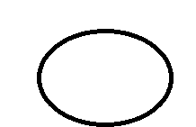

Data flow

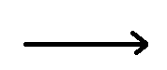

Data store

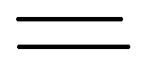

Source / sink



**0 LEVEL DFD**

**1 LEVEL DFD (for user)**

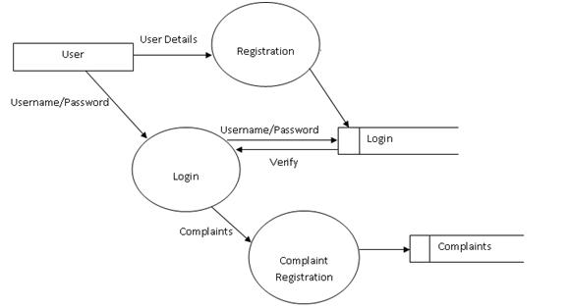

**LEVEL DFD(for admin)**

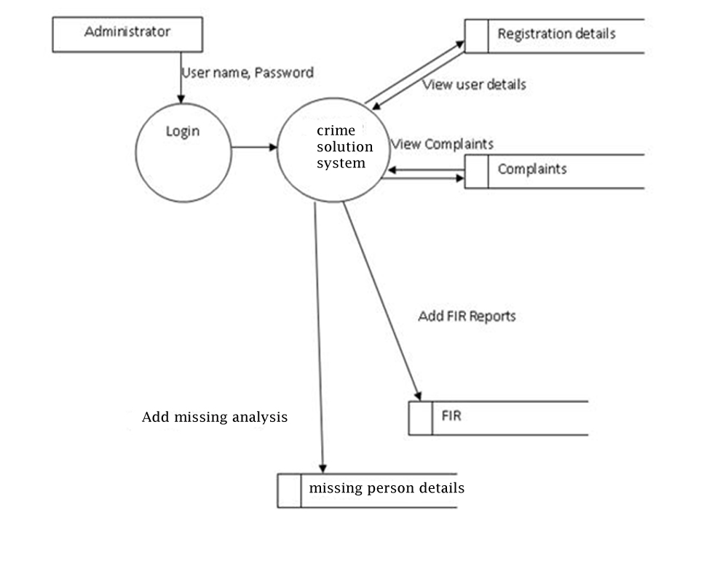

1. **LEVEL DFD(for admin)**

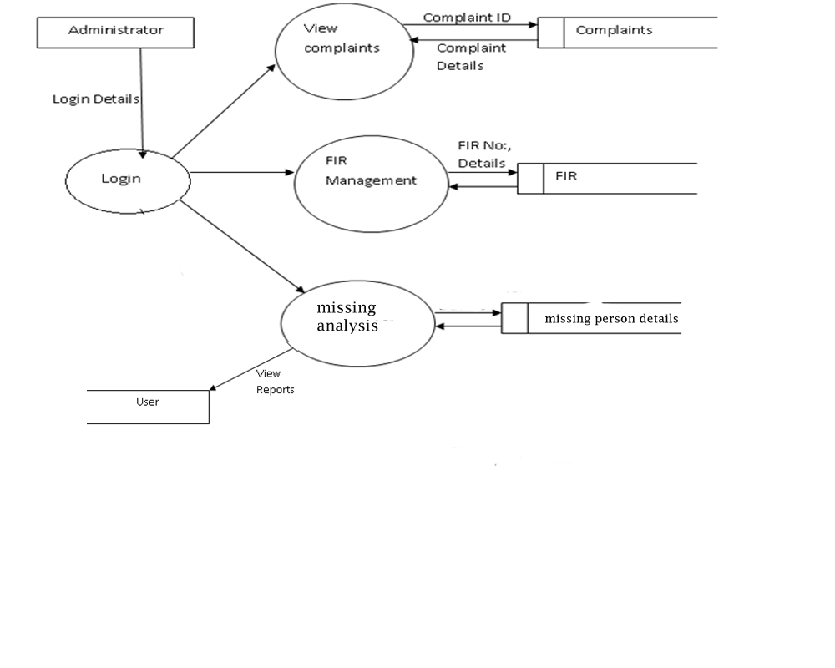

**ER- Diagram**

Definition: An entity-relationship (ER) diagram is a specialized graphic that illustrates the interrelationships between entities in a database. ER diagrams often use symbols to represent three different types of information. Boxes are commonly used to represent entities. Diamonds are normally used to represent relationships and ovals are used to represent attributes.

Also Known As: ER Diagram, E-R Diagram, entity-relationship model

### Entity Relationship Diagram Notations

Peter Chen developed ERDs in 1976. Since then Charles Bachman and James Martin have added some sligh refinements to the basic ERD principles.

##### Entity

An entity is an object or concept about which you want to store information.  
Learn how to edit text on an entity.

Entity

##### Weak Entity

A weak entity is an entity that must defined by a foreign key relationship with another entity as it cannot be uniquely identified by its own attributes alone.  
Learn how to edit text on this object.

Weak Entity

##### Key attribute

A key attribute is the unique, distinguishing characteristic of the entity. For example, an employee's social security number might be the employee's key attribute.

Key attribute

##### Multivalued attribute

A multivalued attribute can have more than one value. For example, an employee entity can have multiple skill values.

Multivalued attribute

##### Derived attribute

A derived attribute is based on another attribute. For example, an employee's monthly salary is based on the employee's annual salary.

Derived attribute

##### Relationships

Relationships illustrate how two entities share information in the database structure.

Learn how to draw relationships:  
First, connect the two entities, then drop the relationship notation on the line

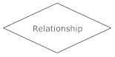

**ER Diagram**

See

status

status

user

complain

complain

Depends on

User

complain

Update

status

admin

Insert

criminal

Update

Missing

person

See

Missing

person

Missing_person

Watch

criminal

criminal

**TOOLS /PLATFORM APPLICATION USED**

**2.1. Hardware Configurations:**

Processor : Pentium 4, higher version

RAM : 512 MB

Hard Disk : 40 GB space

**2.2.Software Configurations:**

Operating System : windows 2000, xp ,vista , windows7

Web Server : Xamp

Technology : PHP

Backend : mysql

Scripting language : php

Web Design : HTML, HTML5, CSS

**About the technology**

* PHP
* WampServer
* HTML
* HTML5
* CSS
* CSS6
* JQUERY
* Java Script
* AJAX
* Adobe photoshop
* Notepad
* MS word
* Dreamweaver cs6

**About HTML**

HTML are initials that stand for HyperText Markup Language (computer people love initials and acronyms -- you'll be talking acronyms ASAP). Let me break it down for you:

* Hyper is the opposite of linear. It used to be that computer programs had to move in a linear fashion. This before this, this before this, and so on. HTML does not hold to that pattern and allows the person viewing the

World Wide Web page to go anywhere, any time they want.

* Text is what you will use. Real, honest to goodness English letters.

* Mark up is what you will do. You will write in plain English and then mark up what you wrote. More to come on that in the next Primer.
* Language because they needed something that started with "L" to finish HTML and Hypertext Markup *Louie* didn't flow correctly. Because it's a language, really -- but the language is plain English.

**HTML tags**

**<!-- -->** Specifies comments

**<A>……….</A>** Creates hypertext links

**<B>……….</B>** Formats text as bold

**<BIG>……….</BIG>** Formats text in large font.

**<BODY>…</BODY>** Contains all tags and text in the HTML document

**<CENTER>...</CENTER>** Creates text

**<DD>…</DD>** Definition of a term

**<DL>...</DL>**  Creates definition list

**<FONT>…</FONT>** Formats text with a particular font

**<FORM>...</FORM>** Encloses a fill-out form

**<FRAME>...</FRAME>** Defines a particular frame in a set of frames

**<H#>…</H#>** Creates headings of different levels

**<HEAD>...</HEAD>** Contains tags that specify information about a document

**<HR>...</HR>** Creates a horizontal rule

**<HTML>…</HTML>** Contains all other HTML tags

**<META>...</META>** Provides meta-information about a document

**<SCRIPT>…</SCRIPT>** Contains client-side or server-side script

**<TABLE>…</TABLE>**  Creates a table

**<TD>…</TD>** Indicates table data in a table

**<TR>…</TR>** Designates a table row

**<TH>…</TH>** Creates a heading in a table

* **ADVANTAGES**
* A HTML document is small and hence easy to send over the net. It is small because it does not include formatted information.
* HTML is platform independent.
* HTML tags are not case-sensitive.

**HYPERTEXT PREPROCESSOR (PHP)**

## PHP

* PHP stands for **P**HP: **H**ypertext **P**reprocessor
* PHP is a powerfull tool for making dynamic and interactive web pages.
* PHP is the widely used, free, and efficient alternative to competitors such as Microsoft’s ASP.
* PHP is a server-side scripting language, like ASP
* PHP scripts are executed on the server
* PHP supports many databases (MySQL, Informix, Oracle, Sybase, Solid, PostgreSQL, Generic ODBC, etc.)
* PHP is an open source software
* PHP is free to download and use

## What is a PHP File

* PHP files can contain text, HTML tags and scripts
* PHP files are returned to the browser as plain HTML
* PHP files have a file extension of ".php", ".php3", or ".phtml"

## Basic PHP Syntax

|  |
| --- |
| <?php ?> |

.

.

## Variables in PHP

All variables in PHP start with a **$** sign symbol.

The correct way of declaring a variable in PHP:

|  |
| --- |
| $var_name = value; |

**BACK END USED**

➢ **MYSQL**

My SQL, the most popular Open Source SQL database management system, is developed,

distributed, and supported by Oracle Corporation.

• **MySQL is a database management system.**

A database is a structured collection of data. It may be anything from a simple shopping

list to a picture gallery or the vast amounts of information in a corporate network. To add,

access, and process data stored in a computer database, you need a database management

system such as MySQL Server. Since computers are very good at handling large amounts

of data, database management systems play a central role in computing, as standalone

utilities, or as parts of other applications.

• **My SQL databases are relational.**

A relational database stores data in separate tables rather than putting all the data in one

big storeroom. The database structures are organized into physical files optimized for

speed. The logical model, with objects such as databases, tables, views, rows, and

columns, offers a flexible programming environment. You set up rules governing the

relationships between different data fields, such as one-to-one, one-to-many, unique,

required or optional, and “pointers” between different tables. The database enforces these

rules, so that with a well-designed database, your application never sees inconsistent,

duplicate, orphan, out-of-date, or missing data.

The SQL part of “My SQL” stands for “Structured Query Language”. SQL is the most

common standardized language used to access databases. Depending on your

programming environment, you might enter SQL directly (for example, to generate

reports), embed SQL statements into code written in another language, or use a languagespecific

API that hides the SQL syntax.

SQL is defined by the ANSI/ISO SQL Standard. The SQL standard has been evolving

since 1986 and several versions exist. In this manual, “SQL-92” refers to the standard

released in 1992, “SQL:1999” refers to the standard released in 1999, and “SQL:2003”

refers to the current version of the standard. We use the phrase “the SQL standard” to

mean the current version of the SQL Standard at any time.

• **My SQL software is Open Source.**

Open Source means that it is possible for anyone to use and modify the software.

Anybody can download the My SQL software from the Internet and use it without paying

anything. If you wish, you may study the source code and change it to suit your needs.

• **The MySQL Database Server is very fast, reliable, scalable, and easy to use.**

If that is what you are looking for, you should give it a try. My SQL Server can run

comfortably on a desktop or laptop, alongside your other applications, web servers, and

so on, requiring little or no attention. If you dedicate an entire machine to My SQL, you

can adjust the settings to take advantage of all the memory, CPU power, and I/O capacity

available. MySQL can also scale up to clusters of machines, networked together. My

SQL Server was originally developed to handle large databases much faster than existing

solutions and has been successfully used in highly demanding production environments

for several years. Although under constant development, My SQL Server today offers a

rich and useful set of functions. Its connectivity, speed, and security make My SQL

Server highly suited for accessing databases on the Internet.

• **My SQL Server works in client/server or embedded systems.**

The My SQL Database Software is a client/server system that consists of a multithreaded

SQL server that supports different backend, several different client programs

and libraries, administrative tools, and a wide range of application programming

interfaces (APIs).

We also provide MySQL Server as an embedded multi-threaded library that you can link

into your application to get a smaller, faster, easier-to-manage standalone product.

• **A large amount of contributed MySQL software is available.**

MySQL Server has a practical set of features developed in close cooperation with our

users. It is very likely that your favorite application or language supports the MySQL.

**ABOUT FRONTEND AND BACKEND**

**ABOUT FRONTEND:**

**Basic PHP Syntax**

A PHP scripting block always starts with <?php and ends with ?>. A PHP scripting block can be placed anywhere in the document.

On servers with shorthand support enabled you can start a scripting block with <? And end with?>.

For maximum compatibility, we recommend that you use the standard form (<?php) rather than the shorthand form.

<?php

?>

Comments in PHP

In PHP, we use // to make a single-line comment or /* and */ to make a large comment block.

<html>

<body>

<?php

//This is a comment

/*

This is

a comment

block

*/

?>

</body>

</html>

Variables in PHP

Variables are used for storing a values, like text strings, numbers or arrays.

When a variable is declared, it can be used over and over again in your script.

All variables in PHP start with a $ sign symbol.

The correct way of declaring a variable in PHP:

$var_name = value;

New PHP programmers often forget the $ sign at the beginning of the variable. In that case it will not work.

creating a variable containing a string, and a variable containing a number:

<?php

$txt="Hello World!";

$x=16;

?>

PHP is a Loosely Typed Language

In PHP, a variable does not need to be declared before adding a value to it.

In the example above, you see that you do not have to tell PHP which data type the variable is.

PHP automatically converts the variable to the correct data type, depending on its value.

In a strongly typed programming language, you have to declare (define) the type and name of the variable before using it.

In PHP, the variable is declared automatically when you use it.

Naming Rules for Variables

• A variable name must start with a letter or an underscore "_"

• A variable name can only contain alpha-numeric characters and underscores (a-z, A-Z, 0-9, and _ )

• A variable name should not contain spaces. If a variable name is more than one word, it should be separated with an underscore ($my_string), or with capitalization ($myString)

A string variable is used to store and manipulate text.

String Variables in PHP

String variables are used for values that contains characters.

In this chapter we are going to look at the most common functions and operators used to manipulate strings in PHP.

After we create a string we can manipulate it. A string can be used directly in a function or it can be stored in a variable.

Below, the PHP script assigns the text "Hello World" to a string variable called $txt:

<?php

$txt="Hello World";

echo $txt;

?>

The output of the code above will be:

Hello World

The Concatenation Operator

There is only one string operator in PHP.

The concatenation operator (.) is used to put two string values together.

To concatenate two string variables together, use the concatenation operator:

<?php

$txt1="Hello World!";

$txt2="What a nice day!";

echo $txt1 . " " . $txt2;

?>

The output of the code above will be:

Hello World! What a nice day!

If we look at the code above you see that we used the concatenation operator two times. This is because we had to insert a third string (a space character), to separate the two strings.

The strlen() function

The strlen() function is used to return the length of a string.

Let's find the length of a string:

<?php

echo strlen("Hello world!");

?>

The output of the code above will be:

12

The length of a string is often used in loops or other functions, when it is important to know when the string ends. (i.e. in a loop, we would want to stop the loop after the last character in the string).

The strpos() function

The strpos() function is used to search for character within a string.

If a match is found, this function will return the position of the first match. If no match is found, it will return FALSE.

Let's see if we can find the string "world" in our string:

<?php

echo strpos("Hello world!","world");

?>

The output of the code above will be:

6

The position of the string "world" in our string is position 6. The reason that it is 6 (and not 7), is that the first position in the string is 0, and not 1.

PHP Operators

Arithmetic Operators

Operator Description Example Result

+ Addition x=2

x+2 4

- Subtraction x=2

5-x 3

* Multiplication x=4

x*5 20

/ Division 15/5

5/2 3

2.5

% Modulus (division remainder) 5%2

10%8

10%2 1

2

0

++ Increment x=5

x++ x=6

-- Decrement x=5

x-- x=4

Assignment Operators

Operator Example Is The Same As

= x=y x=y

+= x+=y x=x+y

-= x-=y x=x-y

*= x*=y x=x*y

/= x/=y x=x/y

.= x.=y x=x.y

%= x%=y x=x%y

Comparison Operators

Operator Description Example

== is equal to 5==8 returns false

!= is not equal 5!=8 returns true

<> is not equal 5<>8 returns true

> is greater than 5>8 returns false

< is less than 5<8 returns true

>= is greater than or equal to 5>=8 returns false

<= is less than or equal to 5<=8 returns true

Logical Operators

Operator Description Example

&& And x=6

y=3

(x < 10 && y > 1) returns true

|| Or x=6

y=3

(x==5 || y==5) returns false

! Not x=6

y=3

!(x==y) returns true

Conditional statements are used to perform different actions based on different conditions.

Conditional Statements

Very often when you write code, you want to perform different actions for different decisions.

You can use conditional statements in your code to do this.

In PHP we have the following conditional statements:

• if statement - use this statement to execute some code only if a specified condition is true

• if...else statement - use this statement to execute some code if a condition is true and another code if the condition is false

• if...elseif....else statement - use this statement to select one of several blocks of code to be executed

• switch statement - use this statement to select one of many blocks of code to be executed

The if Statement

Use the if statement to execute some code only if a specified condition is true.

Syntax

if (condition) code to be executed if condition is true;

The if...else Statement

Use the if....else statement to execute some code if a condition is true and another code if a condition is false.

Syntax

if (condition)

code to be executed if condition is true;

else

code to be executed if condition is false;

If more than one line should be executed if a condition is true/false, the lines should be enclosed within curly braces:

The if...elseif....else Statement

Use the if....elseif...else statement to select one of several blocks of code to be executed.

Syntax

if (condition)

code to be executed if condition is true;

elseif (condition)

code to be executed if condition is true;

else

code to be executed if condition is false;

The PHP Switch Statement

Use the switch statement to select one of many blocks of code to be executed.

Syntax

switch (n)

{

case label1:

code to be executed if n=label1;

break;

case label2:

code to be executed if n=label2;

break;

default:

code to be executed if n is different from both label1 and label2;

}

This is how it works: First we have a single expression n (most often a variable), that is evaluated once. The value of the expression is then compared with the values for each case in the structure. If there is a match, the block of code associated with that case is executed. Use break to prevent the code from running into the next case automatically. The default statement is used if no match is found.

What is an Array

A variable is a storage area holding a number or text. The problem is, a variable will hold only one value.

An array is a special variable, which can store multiple values in one single variable.

If you have a list of items (a list of car names, for example), storing the cars in single variables could look like this:

$cars1="Saab";

$cars2="Volvo";

$cars3="BMW";

However, what if you want to loop through the cars and find a specific one? And what if you had not 3 cars, but 300?

The best solution here is to use an array!

An array can hold all your variable values under a single name. And you can access the values by referring to the array name.

Each element in the array has its own index so that it can be easily accessed.

In PHP, there are three kind of arrays:

• Numeric array - An array with a numeric index

• Associative array - An array where each ID key is associated with a value

• Multidimensional array - An array containing one or more arrays

Numeric Arrays

A numeric array stores each array element with a numeric index.

There are two methods to create a numeric array.

1. In the following example the index are automatically assigned (the index starts at 0):

$cars=array("Saab","Volvo","BMW","Toyota");

2. In the following example we assign the index manually:

$cars[0]="Saab";

$cars[1]="Volvo";

$cars[2]="BMW";

$cars[3]="Toyota";

Associative Arrays

An associative array, each ID key is associated with a value.

When storing data about specific named values, a numerical array is not always the best way to do it.

With associative arrays we can use the values as keys and assign values to them.

Example 1

In this example we use an array to assign ages to the different persons:

$ages = array("Peter"=>32, "Quagmire"=>30, "Joe"=>34);

Example 2

This example is the same as example 1, but shows a different way of creating the array:

$ages['Peter'] = "32";

$ages['Quagmire'] = "30";

$ages['Joe'] = "34";

PHP Loops

Often when you write code, you want the same block of code to run over and over again in a row. Instead of adding several almost equal lines in a script we can use loops to perform a task like this.

In PHP, we have the following looping statements:

• while - loops through a block of code while a specified condition is true

• do...while - loops through a block of code once, and then repeats the loop as long as a specified condition is true

• for - loops through a block of code a specified number of times

• foreach - loops through a block of code for each element in an array

The while Loop

The while loop executes a block of code while a condition is true.

Syntax

while (condition)

{

code to be executed;

}

The do...while Statement

The do...while statement will always execute the block of code once, it will then check the condition, and repeat the loop while the condition is true.

Syntax

do

{

code to be executed;

}

while (condition);

The for Loop

The for loop is used when you know in advance how many times the script should run.

Syntax

for (init; condition; increment)

{

code to be executed;

}

Parameters:

• init: Mostly used to set a counter (but can be any code to be executed once at the beginning of the loop)

• condition: Evaluated for each loop iteration. If it evaluates to TRUE, the loop continues. If it evaluates to FALSE, the loop ends.

• increment: Mostly used to increment a counter (but can be any code to be executed at the end of the loop)

Note: Each of the parameters above can be empty, or have multiple expressions (separated by commas).

The foreach Loop

The foreach loop is used to loop through arrays.

Syntax

foreach ($array as $value)

{

code to be executed;

}

For every loop iteration, the value of the current array element is assigned to $value (and the array pointer is moved by one) - so on the next loop iteration, you'll be looking at the next array value.

PHP Functions

In this chapter we will show you how to create your own functions.

To keep the script from being executed when the page loads, you can put it into a function.

A function will be executed by a call to the function. You may call a function from anywhere within a page.

Create a PHP Function

A function will be executed by a call to the function.

Syntax

function functionName()

{

code to be executed;

}

PHP function guidelines:

• Give the function a name that reflects what the function does

• The function name can start with a letter or underscore (not a number)

PHP Functions - Adding parameters

To add more functionality to a function, we can add parameters. A parameter is just like a variable.

Parameters are specified after the function name, inside the parentheses.

**PHP Form Handling**

The most important thing to notice when dealing with HTML forms and PHP is that any form element in an HTML page will automatically be available to your PHP scripts.

Form Validation

User input should be validated on the browser whenever possible (by client scripts). Browser validation is faster and reduces the server load.

You should consider server validation if the user input will be inserted into a database. A good way to validate a form on the server is to post the form to itself, instead of jumping to a different page. The user will then get the error messages on the same page as the form. This makes it easier to discover the error.

The $_GET Function

The built-in $_GET function is used to collect values from a form sent with method="get".

Information sent from a form with the GET method is visible to everyone (it will be displayed in the browser's address bar) and has limits on the amount of information to send (max. 100 characters).

Example

<form action="welcome.php" method="get">

Name: <input type="text" name="fname" />

Age: <input type="text" name="age" />

<input type="submit" />

</form>

When the user clicks the "Submit" button, the URL sent to the server could look something like this:

http://www.w3schools.com/welcome.php?fname=Peter&age=37

The "welcome.php" file can now use the $_GET function to collect form data (the names of the form fields will automatically be the keys in the $_GET array):

Welcome <?php echo $_GET["fname"]; ?>.<br />

You are <?php echo $_GET["age"]; ?> years old!

When to use method="get"?

When using method="get" in HTML forms, all variable names and values are displayed in the URL.

Note: This method should not be used when sending passwords or other sensitive information!

However, because the variables are displayed in the URL, it is possible to bookmark the page. This can be useful in some cases.

Note: The get method is not suitable for large variable values; the value cannot exceed 100 characters.

The built-in $_POST function is used to collect values in a form with method="post".

The $_POST Function

The built-in $_POST function is used to collect values from a form sent with method="post".

Information sent from a form with the POST method is invisible to others and has no limits on the amount of information to send.

Note: However, there is an 8 Mb max size for the POST method, by default (can be changed by setting the post_max_size in the php.ini file).

Example

<form action="welcome.php" method="post">

Name: <input type="text" name="fname" />

Age: <input type="text" name="age" />

<input type="submit" />

</form>

When the user clicks the "Submit" button, the URL will look like this:

http://www.w3schools.com/welcome.php

The "welcome.php" file can now use the $_POST function to collect form data (the names of the form fields will automatically be the keys in the $_POST array):

Welcome <?php echo $_POST["fname"]; ?>!<br />

You are <?php echo $_POST["age"]; ?> years old.

When to use method="post"

Information sent from a form with the POST method is invisible to others and has no limits on the amount of information to send.

However, because the variables are not displayed in the URL, it is not possible to bookmark the page.

The PHP $_REQUEST Function

The PHP built-in $_REQUEST function contains the contents of both $_GET, $_POST, and $_COOKIE.

The $_REQUEST function can be used to collect form data sent with both the GET and POST methods.

Example

Welcome <?php echo $_REQUEST["fname"]; ?>!<br />

You are <?php echo $_REQUEST["age"]; ?> years old.

**About Backend:-**

**What is SQL?**

• SQL stands for Structured Query Language

• SQL lets you access and manipulate databases

• SQL is an ANSI (American National Standards Institute) standard

**What Can SQL do?**

• SQL can execute queries against a database

• SQL can retrieve data from a database

• SQL can insert records in a database

SQL can update records in a database

• SQL can delete records from a database

• SQL can create new databases

• SQL can create new tables in a database

• SQL can create stored procedures in a database

• SQL can create views in a database

• SQL can set permissions on tables, procedures, and views

**SQL is a Standard - BUT....**

Although SQL is an ANSI (American National Standards Institute) standard, there are many different versions of the SQL language.

However, to be compliant with the ANSI standard, they all support at least the major commands (such as SELECT, UPDATE, DELETE, INSERT, WHERE) in a similar manner.

**Using SQL in Your Web Site**

To build a web site that shows some data from a database, you will need the following:

• An RDBMS database program (i.e. MS Access, SQL Server, MySQL)

• A server-side scripting language, like PHP or ASP

• SQL

• HTML / CSS

**RDBMS:-**

RDBMS stands for Relational Database Management System.

RDBMS is the basis for SQL, and for all modern database systems like MS SQL Server, IBM DB2, Oracle, MySQL, and Microsoft Access.

The data in RDBMS is stored in database objects called tables.

A table is a collection of related data entries and it consists of columns and rows.

**PHP + MySQL:-**

• PHP combined with MySQL are cross-platform (you can develop in Windows and serve on a Unix platform)

**SCREEN SHOT LAYOUT**

**REPORT**

Name – Rajani Sharma

Roll No – 12MCRMS97032

Reg. No. – 1297032

Address – Ranchi

Contact No. – 8877070232

E – Mail – rajanisharma8787@yahoo.com

**Date Subject Topic From To**

**Duration**

25-01-2015 HTML Introduction 10 a. m. 5 p. m.

7 Hours

27-01-2015 Tags of HTML 10 a. m. 5 p. m.

7 Hours

28-01-2015 Creating Tables 10 a. m. 5 p. m.

7 Hours

05-02-2015 Frame Set 10 a. m. 5 p. m.

7 Hours

20-02-2015 Form Designing 10 a. m. 5 p. m.

7 Hours

25-02-2015 CSS Introduction 10 a. m. 5 p. m.

7 Hours

27-02-2015 Grouping 10 a. m. 5 p. m.

7 Hours

01-03-2015 Properties 10 a. m. 5 p. m.

7 Hours

05-03-2015 Class 10 a. m. 5 p. m.

7 Hours

10-03-2015 Scroll 10 a. m. 5 p. m.

7 Hours

15-03-2015 Java Script Introduction 10 a. m. 5 p. m.

7 Hours

20-03-2015 Events 10 a. m. 5 p. m. 7

Hours

25-03-2015 Properties 10 a. m. 5 p. m.

7 Hours

**Date Subject Topic From To**

**Duration**

05-04-2015 PHP Introduction 10 a. m. 5 p. m.

7 Hours

12-04-2015 Connectivity 10 a. m. 5 p. m.

7 Hours

18-04-2015 Validation 10 a. m. 5 p. m.

7 Hours

20-04-2015 MYSQL Introduction 10 a. m. 5 p. m.

7 Hours

22-04-2015 Joining Tables 10 a. m. 5 p. m.

7 Hours

24-04-2015 Query Execution 10 a. m. 5 p. m. 7

Hours

**Date Subject From To**

**Duration**

26-04-2014

To Developing 10 a. m. 5 p. m. 7

Hours

05-05-2015 Project

**DATABASE STRUCTURE**

TABLE : FIR Registration

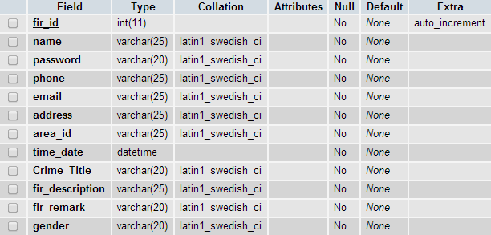

TABLE : a_status

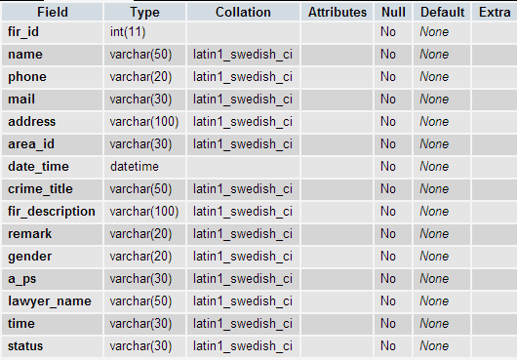

TABLE : criminal

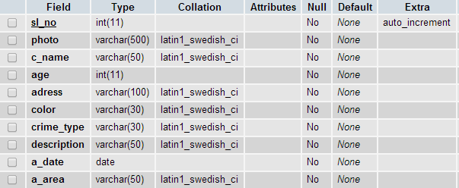

TABLE : missing_person

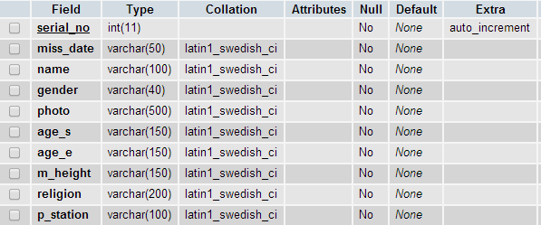

TABLE : telephone

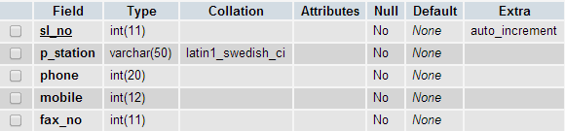

Table:Senior_Citizen

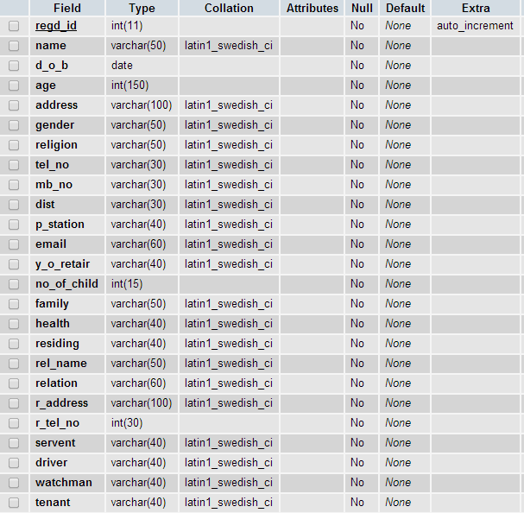

**Home Page For Online Crime Solution System**

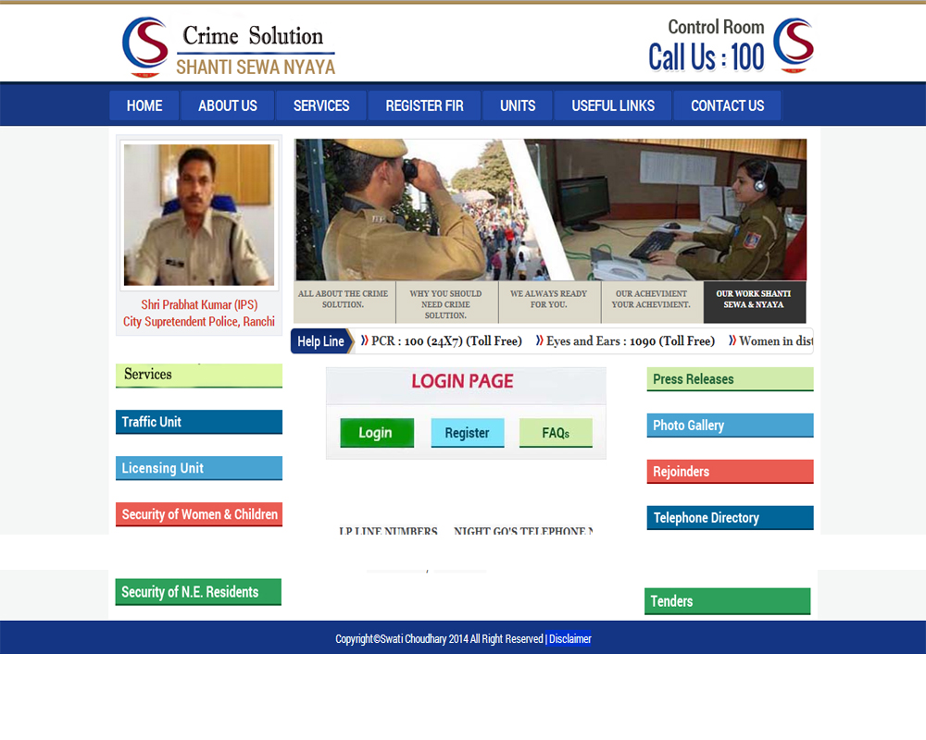

**Source-Code**

;<!DOCTYPE html PUBLIC "-//W3C//DTD XHTML 1.0 Transitional//EN" "http://www.w3.org/TR/xhtml1/DTD/xhtml1-transitional.dtd">

<html xmlns="http://www.w3.org/1999/xhtml">

<head>

<meta http-equiv="Content-Type" content="text/html; charset=utf-8" />

<title>:: CRIME CONTROL Shanti Sewa Nyaya ::</title>

<!--dropdown script start here-->

<script type="text/javascript" src="jquery.min.js"></script>

<script type="text/javascript" src="flexdropdown.js"></script>

<link rel="stylesheet" type="text/css" href="flexdropdown.css">

<link rel="stylesheet" type="text/css" href="general.css">

<link rel="stylesheet" type="text/css" href="style1.css" />

<link href="layout.css" rel="stylesheet" type="text/css" />

<link href="featured_slide.css" rel="stylesheet" type="text/css" />

<script type="text/javascript" src="jquery-1.4.1.min.js"></script>

<script type="text/javascript" src="jquery-ui-1.7.2.custom.min.js"></script>

<script type="text/javascript" src="jquery.tabs.setup.js"></script>

<!--dropdown script start here-->

</head>

<body>

<div class="top-boredr"></div>

<div class="header-main">

<div class="headers">

<div class="header">

<div class="logo1"><a href="#"><img src="image/logo1.png" alt="" width="326" height="87" border="0"></a><a href="#"></a>

</div>

<div class="lef-top-icon-logo"><img src="image/logo2.png" width="254" height="76" alt=""></div>

</div>

</div>

</div>

<div class="button-main">

<div class="btn">

<ul>

<li><a href="index1.php">HOME</a></li>

<li><a href="#" data-flexmenu="flexmenu1" stylez="position:relative;left:900px;top:200px">ABOUT US</a></li>

<li><a href="#" data-flexmenu="flexmenu2" stylez="position:relative;left:900px;top:200px">SERVICES</a><span class="btn-line"></span></li>

<li><a href="#" data-flexmenu="flexmenu3" stylez="position:relative;left:900px;top:200px" class="">REGISTER FIR</a></li>

<li><a href="#" data-flexmenu="flexmenu4" stylez="position:relative;left:900px;top:200px" class="">UNITS</a></li>

<li><a href="#" data-flexmenu="flexmenu5" stylez="position:relative;left:900px;top:200px" class="">USEFUL LINKS</a></li>

<li><a href="#" data-flexmenu="flexmenu6" stylez="position:relative;left:900px;top:200px">CONTACT US</a></li>

</ul>

<map name="Map" id="Map">

<area shape="rect" coords="19,61,129,96" href="login.php" alt="">

<area shape="rect" coords="152,61,261,96" href="admin-registration.php" alt="">

<area shape="rect" coords="281,61,388,96" href="#" target="_blank" alt="">

</map>

<ul id="flexmenu1" class="flexdropdownmenu jqflexmenu" style="display: none; visibility: visible; z-index: 1000;">

<li><a href="history-police.php">History</a></li>

<li><a href="citizen-charter.php">Citizens' Charter</a></li>

<li><a href="#">Former Commissioners</a></li>

<li><a href="medals.php">Medals</a></li>

<li><a href="#">Appreciation letters from public</a></li>

</ul>

<ul id="flexmenu2" class="flexdropdownmenu jqflexmenu" style="display: none; visibility: visible; z-index: 1000;">

<li><a href="missing-person.php">Missing Persons</a></li>

<li><a href="senior citizen.php">Senior Citizens Registration</a></li>

<li><a href="#">Downlodable Forms</a></li>

<li><a href="passport.php">Guidelines / Information in c/w passport verification and registration of Pakistan National</a></li>

<li><a href="mess-acco.php">Go's Mess Accommodation &amp; Tariff</a></li>

</ul>

<ul id="flexmenu3" class="flexdropdownmenu jqflexmenu" style="visibility: visible; z-index: 1003; left: 534px; top: 152px; display: none;">

<li><a href="fir-register.php">Registration-form</a></li>

</ul><ul id="flexmenu4" class="flexdropdownmenu jqflexmenu" style="visibility: visible; z-index: 1002; left: 684px; top: 152px; display: none;">

<li><a href="#">Recruitment Cell</a></li>

<li><a href="mounted-police.php">Mounted Police</a></li>

</ul>

<ul id="flexmenu5" class="flexdropdownmenu jqflexmenu" style="visibility: visible; z-index: 1001; left: 788px; top: 152px; display: none;">

<li><a href="#">what is section 144</a></li>

<li><a href="#">Help Lines</a></li>

<li><a href="about fund.php">About Funds</a></li>

<li><a href="notification1.html">Notification</a></li>

</ul>

<ul id="flexmenu6" class="flexdropdownmenu jqflexmenu" style="display: none; visibility: visible; z-index: 1000;">

<li><a href="#">E-mail Us</a></li>

<li><a href="telephone_directory.php">Telephone Directory</a></li>

</ul>

</div>

</div>

<div class="center-page-main">

<div class="wraper">

<div class="main">

<div class="left-side-page-index">

<div class="img-main-in1">

<div class="img1-1">

<div class="imgage">

<a href="#" target="_blank"><img src="image/SP-ranchi.jpeg" alt="" width="218" height="168" border="0"></a>

</div>

</div>

<div class="text-im1">Shri Prabhat Kumar (IPS)<br>

City Supretendent Police, Ranchi

</div>

</div>

<div></div><br>

<table width="100%" border="0" cellspacing="0" cellpadding="0" style="float:left; clear:both;">

<tbody>

<tr>

<td>&nbsp;</td>

</tr>

<tr>

<td height="17"></td>

</tr>

<tr>

<td><a href="service.php"><img src="image/rti-manual.jpg" width="242" height="29" alt=""></a></td>

</tr>

<tr>

<td>&nbsp;</td>

</tr>

<tr>

<td height="10"></td>

</tr>

<tr>

<td><a href="traffic.php" target="_self"><img src="image/traffic-unit.jpg" width="242" height="29" alt=""></a></td>

</tr>

<tr>

<td>&nbsp;</td>

</tr>

<tr>

<td height="10"></td>

</tr>

<tr>

<td><a href="licencing.php" target="_self"><img src="image/licensing-unit.jpg" width="242" height="29" alt=""></a></td>

</tr>

<tr>

<td>&nbsp;</td>

</tr>

<tr>

<td height="10"></td>

</tr>

<tr>

<td><a href="security_of_women_children.php"><img src="image/women-helpline-tab.jpg" width="242" height="29" alt=""></a></td>

</tr>

<tr>

<td height="10"></td>

</tr>

<tr>

<td>&nbsp;</td>

</tr>

<tr>

<td><a href="ne-resident.php"><img src="image/security-of-ne-res.jpg" width="242" height="29" alt=""></a></td>

</tr>

</tbody></table>

</div>

<div class="right-index-main">

<div id="featured_slide" class="clear">

<!-- ###### -->

<div class="overlay_left"></div>

<div id="featured_content">

<div class="featured_box" id="fc1"><img src="image/slid1.jpg" alt="" />

</div>

<div class="featured_box" id="fc2"><img src="image/slid2.jpg" alt="" />

</div>

<div class="featured_box" id="fc3"><img src="image/slid3.jpg" alt="" />

</div>

<div class="featured_box" id="fc4"><img src="image/slid4.jpg" alt="" />

</div>

<div class="featured_box" id="fc5"><img src="image/slid5.jpg" alt="" />

</div>

</div>

<ul id="featured_tabs">

<li><a href="#fc1">All About The Crime Solution.</a></li>

<li><a href="#fc2">Why You Should need Crime Solution.</a></li>

<li><a href="#fc3">We Always ready for you.</a></li>

<li><a href="#fc4">Our Acheviment Your Acheviment.</a></li>

<li class="last"><a href="#fc5">Our Work Shanti Sewa &amp; Nyaya</a></li>

</ul>

<!-- ###### -->

</div>

<!---Slider is end---->

<div class="news-flash-heading"><img src="image/help-line-head.png" width="95" height="32" alt=""></div>

<div class="news-flash">

<marquee behavior="scroll" direction="left" onmouseover="this.stop();" onmouseout="this.start();" scrollamount="4">

<img src="image/healp-line-bullet.png" width="11" height="13" alt="">&nbsp;PCR : <span>100 (24X7) (Toll Free)</span>&nbsp;&nbsp;&nbsp;&nbsp;&nbsp;<img src="image/healp-line-bullet.png" width="11" height="13" alt="">&nbsp;Eyes and Ears : <span>1090 (Toll Free)</span>&nbsp;&nbsp;&nbsp;&nbsp;&nbsp;<img src="image/healp-line-bullet.png" width="11" height="13" alt="">&nbsp;Women in distress : <span>1091</span>&nbsp;&nbsp;&nbsp;&nbsp;&nbsp;<img src="image/healp-line-bullet.png" width="11" height="13" alt="">&nbsp;Special Cell (North-Eastern States) : <span>1093</span>&nbsp;&nbsp;&nbsp;&nbsp;&nbsp;<img src="image/healp-line-bullet.png" width="11" height="13" alt="">&nbsp;Missing Persons : <span>1094, 23241210</span>&nbsp;&nbsp;&nbsp;&nbsp;&nbsp;<img src="image/healp-line-bullet.png" width="11" height="13" alt="">&nbsp;Traffic : <span>1095, 25844444</span>&nbsp;&nbsp;&nbsp;&nbsp;&nbsp;<img src="image/healp-line-bullet.png" width="11" height="13" alt="">&nbsp;Senior Citizen : <span>1291</span>&nbsp;&nbsp;&nbsp;&nbsp;&nbsp;<img src="image/healp-line-bullet.png" width="11" height="13" alt="">&nbsp;Vigilance : <span>1064</span>

</marquee>

</div>

<div class="clr"></div>

<table width="100%" border="0" cellspacing="0" cellpadding="0">

<tbody><tr>

<td><table width="100%" border="0" cellspacing="0" cellpadding="0">

<tbody><tr>

<td align="center" valign="top"><table border="0" cellspacing="0" cellpadding="0">

<tbody><tr>

<td><em><img src="image/lost-report-img.jpg" alt="" width="407" height="110" border="0" usemap="#Map"></em></td>

</tr>

<tr>

<td height="25">&nbsp;</td>

</tr>

<tr>

<td>

<div class="news-flash-bott1">

<table width="95%" border="0" align="center" cellpadding="0" cellspacing="0">

<tbody><tr>

<td>&nbsp;</td>

</tr>

<tr>

<td>&nbsp;</td>

</tr>

<tr>

<td height="5"></td>

</tr>

<tr>

<td><marquee behavior="scroll" direction="left" onmouseover="this.stop();" onmouseout="this.start();" scrollamount="4" width="100%">

<a href="#" target="_blank">Annual Review 2013</a>

&nbsp;&nbsp;&nbsp;&nbsp;

<a href="#" target="_blank">Women Help line Numbers</a>

&nbsp;&nbsp;&nbsp;&nbsp;

<a href="#" target="_blank"> Night GO's Telephone Numbers</a>

&nbsp;&nbsp;&nbsp;&nbsp;

<a href="#" target="_blank">REWARD FOR GIVING INFORMATION</a>

&nbsp;&nbsp;&nbsp;&nbsp;

Follow Ranchi Traffic Police on

<a href="#" target="_blank">facebook </a>/

<a href="#" target="_blank">twitter</a></marquee></td>

</tr>

</tbody></table>

</div>

</td>

</tr>

</tbody></table></td>

<td width="33%" align="right" valign="top"><table border="0" cellspacing="0" cellpadding="0">

<tbody><tr>

<td>

<a href="press_releases.php"><img src="image/media-press.jpg" width="242" height="29" alt=""></a>

</td>

</tr>

<tr>

<td height="10"></td>

</tr>

<tr>

<td>&nbsp;</td>

</tr>

<tr>

<td>

<a href="#"><img src="image/photo-gall.jpg" width="242" height="29" alt=""></a>

</td>

</tr>

<tr>

<td height="10"></td>

</tr>

<tr>

<td>&nbsp;</td>

</tr>

<tr>

<td>

<a href="rejoind.php"><img src="image/rejoinders.jpg" width="242" height="29" alt=""></a>

</td>

</tr>

<tr>

<td height="10"></td>

</tr>

<tr>

<td>&nbsp;</td>

</tr>

<tr>

<td>

<a href="telephone_directory.php"><img src="image/department-contacts.jpg" width="242" height="29" alt=""></a>

</td>

</tr>

<tr>

<td>&nbsp;</td>

</tr>

<tr>

<td height="10"></td>

</tr>

<tr>

<td>

<a href="tender.php" target="_self"><img src="image/tenders.jpg" width="242" height="29" alt=""></a>

</td>

</tr>

</tbody></table></td>

</tr>

</tbody></table></td>

</tr>

<tr>

<td height="5"></td>

</tr>

</tbody></table>

</div>

</div>

</div>

</div>

<div class="footer-main">

<div class="footer">

<table border="0" align="center" cellpadding="0" cellspacing="0">

<tbody><tr>

<td align="center" style="margin-top:10px;">Copyright©Swati Choudhary 2014 All Right Reserved </td>

<td align="right">&nbsp;</td>

<td align="right"><a href="#" class="white-link">| Disclaimer</a></td>

</tr>

</tbody></table>

</div>

</div>

</body>

</html>

**Flexdropdown.css**

#marquee

{

width:400px;

height:170px;

border:solid;

background-color:#0C3;

}

Body

{

margin: 0px;

padding: 0px;

font-family: 'Roboto', sans-serif;

font-size:14px;

}

.top-boredr

{

background-color: #b0915b;

float: left;

height: 3px;

width: 100%;

border-bottom-width: 1px;

border-bottom-style: solid;

border-bottom-color: #886a36;

}

.header-main

{

float: left;

height: auto;

width: 100%;

background-color: #FFF;

}

.headers

{

height: auto;

width: 1033px;

margin-right: auto;

margin-left: auto;

}

.header

{

float: left;

height: auto;

width: 1033px;

}

.logo1

{

float: left;

height: 87px;

width: 326px;

margin-top: 5px;

margin-left:10px;

}

.in-eamil-id-top

{

float: left;

height: 38px;

width: 388px;

margin-left: 20px;

}

.email-id-in-text

{

font-family: Roboto;

font-size: 17px;

color: #FFF;

float: left;

height: auto;

width: 338px;

margin-left: 25px;

}

.email-id-in-text table tr td a

{

color: #FFF;

text-decoration: none;

}

.lef-top-icon-logo

{

float: right;

height: 76px;

width: 254px;

margin-top: 10px;

}

.button-main

{

background-color: #183883;

float: left;

height: 48px;

width: 100%;

margin:0px auto;

margin-top: 3px;

border-top-width: 1px;

border-bottom-width: 1px;

border-top-style: solid;

border-bottom-style: solid;

border-top-color: #0f2459;

border-bottom-color: #0f2459;

}

.btn

{

height: 48px;

width: 1033px;

margin:0px auto;

}

.btn ul

{

padding:0px;

margin:0px auto;

margin-top:6px;

}

.btn li

{

display: inline;

margin: 0px auto;

text-align: center;

border-right: 1px solid #214aa9;

float:left;

}

.btn a

{

font-family: Roboto;

font-size: 18px;

color: #FFF;

background-color:#214aa9;

text-decoration: none;

border: 1px solid #183883;

border-radius:3px;

font-weight:500;

display:block;

border-right: 1px solid #112960;

padding:0px 25px;

line-height:35px;

}

.btn a:hover

{

border: 1px solid #FFF;

}

.btn .active

{

border: 1px solid #FFF;

}

.center-page-main

{

float: left;

height: auto;

width: 100%;

background-color: #f5f7f6;

}

.wraper

{

background-color: #FFF;

width: 1033px;

margin-right: auto;

margin-left: auto;

}

.main

{

background-color: #FFF;

float: left;

height: auto;

width: 1033px;

}

.left-side-page-index

{

width: 242px;

float: left;

margin-top: 10px;

margin-left: 10px;

}

.img-main-in1

{

width: 240px;

float: left;

background-color: #f2f3f5;

border: 1px solid #e3e7f2;

}

.line-left1

{

background-color: #d33727;

float: left;

height: 5px;

width: 242px;

}

.right-index-main

{

float: right;

width: 760px;

margin-top: 10px;

margin-right: 10px;

}

.banner

{

float: left;

height: auto;

width: 760px;

}

.line-left2

{

background-color: #173781;

float: left;

height: 5px;

width: 242px;

}

.line-left3

{

background-color: #b28f5c;

float: left;

height: 5px;

width: 242px;

}

.img-main-in2

{

width: 240px;

float: left;

background-color: #f2f3f5;

border: 1px solid #e3e7f2;

margin-top: 19px;

}

.img-main-in3

{

width: 240px;

float: left;

background-color: #f2f3f5;

border: 1px solid #e3e7f2;

margin-top: 25px;

}

.img-main-in5

{

width: 240px;

float: left;

background-color: #f2f3f5;

border: 1px solid #e3e7f2;

margin-top: 14px;

height:134px;

padding:5px 0px;

}

.imgage

{

float: left;

height: 180px;

width: 218px;

margin-top: 5px;

margin-left: 5px;

}

.img1

{

float: left;

height: 227px;

width: 229px;

margin-left: 5px;

margin-top: 5px;

background-color: #FFF;

border: 1px solid #d5d5d7;

margin-bottom: 5px;

}

.img1-1

{

float: left;

height: 179px;

width: 229px;

margin-left: 5px;

margin-top: 5px;

background-color: #FFF;

border: 1px solid #d5d5d7;

margin-bottom: 5px;

}

.img1-2

{

float: left;

height: 157px;

width: 229px;

margin-left: 5px;

margin-top: 5px;

background-color: #FFF;

border: 1px solid #d5d5d7;

margin-bottom: 5px;

}

.text-im1

{

font-family: Roboto;

font-size: 15px;

font-weight: bold;

color: #d33727;

float: left;

height: auto;

width: 228px;

margin-top: 0px;

margin-bottom: 7px;

margin-left: 6px;

text-align: center;

}

.text-im2

{

font-family: Roboto;

font-size: 18px;

font-weight: bold;

color: #173781;

float: left;

height: auto;

width: 228px;

margin-top: 10px;

margin-bottom: 10px;

margin-left: 6px;

text-align: center;

}

.text-im3

{

font-family: Roboto;

font-size: 18px;

font-weight: bold;

color: #b28f5c;

float: left;

height: auto;

width: 228px;

margin-top: 10px;

margin-bottom: 10px;

margin-left: 6px;

text-align: center;

}

.news-flash

{

background: url(../dp-img/healp-line-in-bg.png) repeat-x;

float: left;

height: 25px;

width: 664px;

border: 1px solid #dbdbdb;

border-radius:0px 5px 5px 0px;

margin-bottom:15px;

border-left:0px;

padding-top:5px;

font-size:15px;

color:#414141;

font-weight:700;

}

.news-flash span

{

color:#242424;

font-weight:900;

}

.news-flash-heading

{

float: left;

height: 30px;

width: 95px;

font-family: Roboto;

font-size: 18px;

font-weight: bold;

color: #FFF;

}

.news-flash-heading img

{

border-radius: 5px 0px 0px 5px

}

.nes-marquee

{

float: left;

width: 620px;

font-family: Roboto;

font-size: 15px;

color: #414141;

margin-top:5px;

}

.marque1

{

width: auto;

margin-left: 10px;

font-weight: bold;

float: left;

height: 50px;

}

.boxes-main

{

float: left;

width: 760px;

margin-top:0px;

}

.hh1

{

font-weight: bold;

}

.box-main1

{

height: auto;

width: 760px;

margin-bottom: 20px;

}

.box-main2

{

float: left;

height: auto;

width: 760px;

margin-top:23px;

}

.box1

{

background-image: url(../dp-img/media-bg.jpg);

float: left;

width: 220px;

height: 100px;

margin-right:50px;

border-bottom-width: 3px;

border-bottom-style: solid;

border-right-color: #0589A9;

}

.box1-1

{

background:#d1ebac;

float: left;

width: 220px;

height: 130px;

margin-right:50px;

border:1px solid #bad593;

color:#fff;

}

.box1-2

{

background:#66b7e1;

float: left;

width: 220px;

height: 130px;

margin-right:40px;

border:1px solid #4696bf;

color:#fff;

}

.box2

{

background-image: url(../dp-img/box2.jpg);

float: right;

height: 130px;

width: 220px;

border-bottom-width: 3px;

border-bottom-style: solid;

border-bottom-color: #D33727;

}

.box3

{

background-image: url(../dp-img/special-police-unit.jpg);

float: left;

height: 130px;

border-bottom-width: 3px;

border-bottom-style: solid;

border-bottom-color: #D9C67F;

width:220px;

}

.box4

{

background-image: url(../dp-img/commissioner-bg.jpg);

float: right;

height: 130px;

width: 220px;

border-bottom-width: 3px;

border-bottom-style: solid;

border-bottom-color: #1D44A0;

}

.box-under-text1

{

height: auto;

width: 120px;

margin-top: 5px;

margin-left: 25px;

font-family: Roboto;

font-size: 13px;

line-height: 22px;

color: #2d3d41;

}

.box-under-text2

{

float: right;

height: auto;

width: 180px;

margin-top: 25px;

font-family: Roboto;

font-size: 13px;

line-height: 22px;

color: #2b2b2b;

margin-right: 25px;

}

.box-heading-text1

{

font-family: Roboto;

font-size: 16px;

font-weight: bold;

color: #FFF;

background-color: #0589a9;

float: left;

height: 27px;

width: 180px;

padding-top: 2px;

text-align: center;

}

.box-heading-text2

{

font-family: Roboto;

font-size: 16px;

font-weight: bold;

color: #FFF;

background-color: #d33727;

float: left;

height: 27px;

width: 170px;

padding-left: 10px;

padding-top: 2px;

}

.box-heading-text3

{

font-family: Roboto;

font-size: 16px;

font-weight: bold;

color: #20655e;

background-color: #d9c67f;

float: left;

height: 27px;

width: 150px;

padding-left: 10px;

padding-top: 2px;

}

.box-heading-text4

{

font-family: Roboto;

font-size: 16px;

font-weight: bold;

color: #FFF;

background-color: #1d44a0;

float: left;

height: auto;

width: 170px;

padding-left: 10px;

padding-top: 2px;

padding-bottom: 3px;

}

.teaxt-parag

{

float: left;

height: auto;

width: 180px;

margin-top: 5px;

font-size: 14px;

}

.teaxt-parag1

{

float: left;

height: auto;

width: 140px;

margin-top: 5px;

font-size: 14px;

}

.teaxt-parag2

{

float: left;

height: auto;

width: 180px;

margin-top: 5px;

font-size: 14px;

color:#243620;

}

.mire-box

{

float: left;

height: auto;

width: 180px;

margin-top: 2px;

font-size: 14px;

font-weight: bold;

color: #00566b;

line-height: normal;

}

.mire-box table tr td a

{

color: #0589A9;

text-decoration: none;

}

.mire-box2

{

float: left;

height: auto;

width: 180px;

margin-top: 2px;

font-size: 14px;

font-weight: bold;

color: #00566b;

line-height: normal;

}

.footer-main

{

background-color: #143584;

float: left;

width: 100%;

border-top-width: 1px;

border-top-style: solid;

border-top-color: #FFF;

}

.footer

{

font-family: Roboto;

font-size: 13px;

color: #FFF;

width: 1033px;

margin-top: 10px;

margin-right: auto;

margin-bottom: 10px;

margin-left: auto;

text-align: left;

}

.footerr-m

{

float: left;

margin-top: 10px;

margin-bottom: 10px;

margin-left: 10px;

line-height: normal;

font-size: 13px;

width:100%;

}

.mid_heading

{

font-family: Roboto;

font-size: 16px;

font-weight: bold;

color: #20655e;

background-color: #d9c67f;

height: 27px;

width: 150px;

padding-left: 10px;

padding-top: 2px;

}

.mid_heading-or

{

font-family: Roboto;

font-size: 16px;

font-weight: bold;

color: #20655e;

background-color: #d9c67f;

height: 27px;

width: 150px;

padding-left: 10px;

padding-top: 2px;

}

.punch_logo

{

width:100%;

height:46px;

padding-top:8px;

}

.left_heading

{

float:left;

width:150px;

padding-left:8px;

font-size: 15px;

line-height:22px;

color:#ffffff;

font-family: Roboto;

}

.rit_logo

{

float:right;

width:54px;

padding-right:10px;

}

.rit_logo img

{

width:100%;

}

.rit_logo1

{

float:right;

width:54px;

padding-right:10px;

}

.clr

{

clear:both;

}

.right_help

{

float:right;

width:220px;

height:80px;

}

.right_help img

{

width:220px;

height:130px;

}

.right_help-1

{

float:right;

width:220px;

height: 130px;

background:#dcd8da;

border:1px solid #c1b6bc;

}

.sub_heading

{

color:#0c2767;

font-weight:700;

font-family: Roboto;

margin-bottom:0;

}

p.profile_content_left

{

font-family: Roboto;

font-size: 14px;

color: #666;

text-align: left;

height: auto;

width: 760px;

line-height: 22px;

margin-top:0;

}

.profile_content_left

{

font-family: Roboto;

font-size: 14px;

color: #666;

text-align: left;

height: auto;

width: 760px;

line-height: 22px;

margin-top:0;

}

.new-flash

{

color:#484a4c;

text-decoration:none;

text-transform:uppercase;

font-size:13px;

font-weight:500;

}

.new-flash a

{

color:#484a4c;

text-decoration:none;

text-transform:uppercase;

font-size:14px;

font-weight:900;

}

.new-flash a:hover

{

color:#c50606;

}

.news-flash-heading-1

{

color: #173781;

font-family: Roboto;

font-size: 18px;

font-weight: bold;

text-align: center;

}

h2.photo_gall

{

font-size:35px;

margin-bottom:10px;

padding-left:10px;

}

h3.photo_gall

{

font-size:26px;

margin-bottom:10px;

padding-left:10px;

}

h2.photo_gall_title

{

font-size:36px;

margin-bottom:10px;

text-align:center;

}

.help-line-head

{

font-size:28px;

font-weight:700;

color:#c81913;

}

.help-line-text-h

{

font-size:14px;

color:#c81913;

}

.help-line-text-h span

{

font-size:14px;

color:#0e2a6c;

font-weight:700;

}

.help-line-text-h select

{

font-size:13px;

color:#84868a;

border:2px solid #e6e8ea;

padding:5px 5px;

width:230px;

float:right;

clear:both;

font-weight:500;

}

.link-text a

{

font-size:14px;

color:#77797d;

font-weight:500;

text-decoration:none;

}

.link-text1 a

{

font-size:16px;

color:#d33727;

font-weight:700;

text-decoration:none;

background:#ececec;

padding:5px 10px;

border-bottom:2px solid #dbdada;

}

.link-text1 a:hover

{

background:#ececec;

padding:5px 10px;

border-bottom:2px solid #c1cdea;

color:#173781;

}

.citizens-charter h1

{

font-family: Roboto;

font-size: 30px;

font-weight: bold;

color: #bb291a;

padding:0px;

margin:0px;

}

.citizens-charter h2

{

font-family: Roboto;

font-size: 22px;

color: #173781;

font-weight: 700;

padding:0px;

margin:0px;

}

.citizens-charter h3

{

font-family: Roboto;

font-size: 18px;

color: #434343;

font-weight: 700;

padding:0px;

margin:0px;

}

.citizens-charter h4

{

font-family: Roboto;

font-size: 16px;

color: #5b5b5b;

font-weight: 700;

padding:0px;

margin:0px;

}

.citizens-charter h4 a

{

font-family: Roboto;

font-size: 14px;

color: #1d44a1;

font-weight: 500;

padding:0px;

margin:0px;

text-decoration:none;

}

.citizens-charter h5

{

font-family: Roboto;

font-size: 18px;

color: #173781;

font-weight: 700;

padding:0px;

margin:0px;

text-transform:uppercase;

}

.citizens-charter h5 span

{

font-family: Roboto;

font-size: 14px;

color: #494949;

font-weight: 500;

padding:0px;

margin:0px;

}

.citizens-charter h5 span strong

{

font-size: 16px;

font-weight: 700;

}

.citizens-charter

{

font-family: Roboto;

font-size: 14px;

color: #666;

height: auto;

line-height: 22px;

}

.citizens-charter p

{

font-family: Roboto;

font-size: 14px;

color: #666;

height: auto;

line-height: 22px;

}

.citizens-charter p strong

{

color: #343434;

}

.citizens-charter a

{

font-family: Roboto;

font-size: 14px;

color: #1d44a1;

font-weight: 500;

text-decoration:none;

}

.citizens-charter a:hover

{

text-decoration:underline;

}

a.white-link

{

color:#fff;

background:#03C;

text-decoration:none;

}

.gallery-top-head

{

font-size:19px;

font-weight:700;

color:#d22420;

text-transform:uppercase;

}

.gall-yr-head

{

font-size:24px;

color:#d22420;

font-family:"Times New Roman", Times, serif;

font-style:italic;

font-weight:700;

border-bottom:1px solid #CCCCCC;

padding:0 0 8px 0;

margin:0 0 8px 0;

}

.gall-yr-head a

{

font-size:24px;

color:#d22420;

font-family:"Times New Roman", Times, serif;

font-style:italic;

font-weight:700;

border-bottom:1px solid #CCCCCC;

padding:0 0 8px 0;

margin:0 0 8px 0;

text-decoration:none;

}

.gall-yr-head a:hover

{

text-decoration:underline;

}

.sub-title ul

{

font-size:14px;

font-weight:700;

color:#333333;

padding:0px;

margin:0px;

}

.sub-title ul li

{

list-style:none;

background:url(../dp-img/photo-gallery-img/arrow-bull.jpg) left no-repeat;

display:table;

padding-left:20px;

padding-bottom:10px;

padding-top:10px;

}

.sub-title ul li a

{

color:#333333;

padding:0px;

margin:0px;

text-decoration:none;

font-family:Arial, Helvetica, sans-serif;

font-style:normal;

text-transform:uppercase;

}

.sub-title ul li a:hover

{

color:#d22420;

}

.big-text p

{

color:#333;

line-height:22px;

font-weight:bold;

font-size:14px;

}

a.white-text

{

color:#fff;

}

}

.black-links a

{

color:#333 !important; }

Style.css

#marquee

{

width:400px;

height:170px;

border:solid;

background-color:#0C3;

}

Body

{

margin: 0px;

padding: 0px;

font-family: 'Roboto', sans-serif;

font-size:14px;

}

.top-boredr

{

background-color: #b0915b;

float: left;

height: 3px;

width: 100%;

border-bottom-width: 1px;

border-bottom-style: solid;

border-bottom-color: #886a36;

}

.header-main

{

float: left;

height: auto;

width: 100%;

background-color: #FFF;

}

.headers

{

height: auto;

width: 1033px;

margin-right: auto;

margin-left: auto;

}

.header

{

float: left;

height: auto;

width: 1033px;

}

.logo1

{

float: left;

height: 87px;

width: 326px;

margin-top: 5px;

margin-left:10px;

}

.lef-top-icon-logo

{

float: right;

height: 76px;

width: 254px;

margin-top: 10px;

}

.button-main

{

background-color: #183883;

float: left;

height: 48px;

width: 100%;

margin:0px auto;

margin-top: 3px;

border-top-width: 1px;

border-bottom-width: 1px;

border-top-style: solid;

border-bottom-style: solid;

border-top-color: #0f2459;

border-bottom-color: #0f2459;

}

.btn

{

height: 48px;

width: 1033px;

margin:0px auto;

}

.btn ul

{

padding:0px;

margin:0px auto;

margin-top:6px;

}

.btn li

{

display: inline;

margin: 0px auto;

text-align: center;

border-right: 1px solid #214aa9;

float:left;

}

.btn a

{

font-family: Roboto;

font-size: 18px;

color: #FFF;

background-color:#214aa9;

text-decoration: none;

border: 1px solid #183883;

border-radius:3px;

font-weight:500;

display:block;

border-right: 1px solid #112960;

padding:0px 25px;

line-height:35px;

}

.btn a:hover {

border: 1px solid #FFF;

}

.center-page-main {

float: left;

height: auto;

width: 100%;

background-color: #f5f7f6;

}

.wraper {

background-color: #FFF;

width: 1033px;

margin-right: auto;

margin-left: auto;

}

.main {

background-color: #FFF;

float: left;

height: auto;

width: 1033px;

}

.left-side-page-index {

width: 242px;

float: left;

margin-top: 10px;

margin-left: 10px;

}

.img-main-in1{

width: 240px;

float: left;

background-color: #f2f3f5;

border: 1px solid #e3e7f2;

}

.line-left1 {

background-color: #d33727;

float: left;

height: 5px;

width: 242px;

}

.right-index-main {

float: right;

width: 760px;

margin-top: 10px;

margin-right: 10px;

}

.banner {

float: left;

height: auto;

width: 760px;

}

.line-left2 {

background-color: #173781;

float: left;

height: 5px;

width: 242px;

}

.line-left3 {

background-color: #b28f5c;

float: left;

height: 5px;

width: 242px;

}

.img-main-in2{

width: 240px;

float: left;

background-color: #f2f3f5;

border: 1px solid #e3e7f2;

margin-top: 19px;

}

.img-main-in3{

width: 240px;

float: left;

background-color: #f2f3f5;

border: 1px solid #e3e7f2;

margin-top: 25px;

}

.img-main-in5{

width: 240px;

float: left;

background-color: #f2f3f5;

border: 1px solid #e3e7f2;

margin-top: 14px;

height:134px;

padding:5px 0px;

}

.imgage {

float: left;

height: 180px;

width: 218px;

margin-top: 5px;

margin-left: 5px;

}

.img1 {

float: left;

height: 227px;

width: 229px;

margin-left: 5px;

margin-top: 5px;

background-color: #FFF;

border: 1px solid #d5d5d7;

margin-bottom: 5px;

}

.img1-1 {

float: left;

height: 179px;

width: 229px;

margin-left: 5px;

margin-top: 5px;

background-color: #FFF;

border: 1px solid #d5d5d7;

margin-bottom: 5px;

}

.img1-2 {

float: left;

height: 157px;

width: 229px;

margin-left: 5px;

margin-top: 5px;

background-color: #FFF;

border: 1px solid #d5d5d7;

margin-bottom: 5px;

}

.text-im1 {

font-family: Roboto;

font-size: 15px;

font-weight: bold;

color: #d33727;

float: left;

height: auto;

width: 228px;

margin-top: 0px;

margin-bottom: 7px;

margin-left: 6px;

text-align: center;

}

.text-im2 {

font-family: Roboto;

font-size: 18px;

font-weight: bold;

color: #173781;

float: left;

height: auto;

width: 228px;

margin-top: 10px;

margin-bottom: 10px;

margin-left: 6px;

text-align: center;

}

.text-im3 {

font-family: Roboto;

font-size: 18px;

font-weight: bold;

color: #b28f5c;

float: left;

height: auto;

width: 228px;

margin-top: 10px;

margin-bottom: 10px;

margin-left: 6px;

text-align: center;

}

.news-flash {

background: url(../dp-img/healp-line-in-bg.png) repeat-x;

float: left;

height: 25px;

width: 664px;

border: 1px solid #dbdbdb;

border-radius:0px 5px 5px 0px;

margin-bottom:15px;

border-left:0px;

padding-top:5px;

font-size:15px;

color:#414141;

font-weight:700;

}

.news-flash span {

color:#242424;

font-weight:900;

}

.news-flash-heading {

float: left;

height: 30px;

width: 95px;

font-family: Roboto;

font-size: 18px;

font-weight: bold;

color: #FFF;

}

.news-flash-heading img {

border-radius: 5px 0px 0px 5px

}

.nes-marquee {

float: left;

width: 620px;

font-family: Roboto;

font-size: 15px;

color: #414141;

margin-top:5px;

}

.marque1 {

width: auto;

margin-left: 10px;

font-weight: bold;

float: left;

height: 50px;

}

.boxes-main {

float: left;

width: 760px;

margin-top:0px;

}

.hh1 {

font-weight: bold;

}

.box-main1 {

height: auto;

width: 760px;

margin-bottom: 20px;

}

.box-main2 {

float: left;

height: auto;

width: 760px;

margin-top:23px;

}

.box1-1 {

background:#d1ebac;

float: left;

width: 220px;

height: 130px;

margin-right:50px;

border:1px solid #bad593;

color:#fff;

}

.teaxt-parag {

float: left;

height: auto;

width: 180px;

margin-top: 5px;

font-size: 14px;

}

.teaxt-parag1 {

float: left;

height: auto;

width: 140px;

margin-top: 5px;

font-size: 14px;

}

.teaxt-parag2 {

float: left;

height: auto;

width: 180px;

margin-top: 5px;

font-size: 14px;

color:#243620;

}

.mire-box {

float: left;

height: auto;

width: 180px;

margin-top: 2px;

font-size: 14px;

font-weight: bold;

color: #00566b;

line-height: normal;

}

.footer-main {

background-color: #143584;

float: left;

width: 100%;

border-top-width: 1px;

border-top-style: solid;

border-top-color: #FFF;

}

.footer {

font-family: Roboto;

font-size: 13px;

color: #FFF;

width: 1033px;

margin-top: 10px;

margin-right: auto;

margin-bottom: 10px;

margin-left: auto;

text-align: left;

}

.marq-iframe {

background-image: url(../dp-img/marquee-bg.jpg);

float: left;

height: 45px;

width: 620px;

}

/*---------------- 23.2.14 -------------------*/

.mid_heading {

width: 120px;

margin-top: 5px;

font-family: Roboto;

font-size: 13px;

line-height: 22px;

color: #FFF;

margin-left: 8px;

}

.mid_heading {

font-family: Roboto;

font-size: 16px;

font-weight: bold;

color: #20655e;

background-color: #d9c67f;

height: 27px;

width: 150px;

padding-left: 10px;

padding-top: 2px;

}

.mid_heading-or {

font-family: Roboto;

font-size: 16px;

font-weight: bold;

color: #20655e;

background-color: #d9c67f;

height: 27px;

width: 150px;

padding-left: 10px;

padding-top: 2px;

}

.punch_logo

{

width:100%;

height:46px;

padding-top:8px;

}

.left_heading

{

float:left;

width:150px;

padding-left:8px;

font-size: 15px;

line-height:22px;

color:#ffffff;

font-family: Roboto;

}

.rit_logo

{

float:right;

width:54px;

padding-right:10px;

}

.rit_logo img

{

width:100%;

}

.rit_logo1

{

float:right;

width:54px;

padding-right:10px;

}

.new-flash

{

color:#484a4c;

text-decoration:none;

text-transform:uppercase;

font-size:13px;

font-weight:500;

}

.new-flash a

{

color:#484a4c;

text-decoration:none;

text-transform:uppercase;

font-size:14px;

font-weight:900;

}

.new-flash a:hover

{

color:#c50606;

}

.news-flash-heading-1

{

color: #173781;

font-family: Roboto;

font-size: 18px;

font-weight: bold;

text-align: center;

}

.help-line-head

{

font-size:28px;

font-weight:700;

color:#c81913;

}

.help-line-text-h

{

font-size:14px;

color:#c81913;

}

.help-line-text-h span

{

font-size:14px;

color:#0e2a6c;

font-weight:700;

}

.help-line-text-h select

{

font-size:13px;

color:#84868a;

border:2px solid #e6e8ea;

padding:5px 5px;

width:230px;

float:right;

clear:both;

font-weight:500;

}

.link-text a

{

font-size:14px;

color:#77797d;

font-weight:500;

text-decoration:none;

}

.link-text1 a

{

font-size:16px;

color:#d33727;

font-weight:700;

text-decoration:none;

background:#ececec;

padding:5px 10px;

border-bottom:2px solid #dbdada;

}

.link-text1 a:hover

{

background:#ececec;

padding:5px 10px;

border-bottom:2px solid #c1cdea;

color:#173781;

}

.citizens-charter h1

{

font-family: Roboto;

font-size: 30px;

font-weight: bold;

color: #bb291a;

padding:0px;

margin:0px;

}

.citizens-charter h2

{

font-family: Roboto;

font-size: 22px;

color: #173781;

font-weight: 700;

padding:0px;

margin:0px;

}

.citizens-charter h3

{

font-family: Roboto;

font-size: 18px;

color: #434343;

font-weight: 700;

padding:0px;

margin:0px;

}

.citizens-charter h4

{

font-family: Roboto;

font-size: 16px;

color: #5b5b5b;

font-weight: 700;

padding:0px;

margin:0px;

}

.citizens-charter h4 a

{

font-family: Roboto;

font-size: 14px;

color: #1d44a1;

font-weight: 500;

padding:0px;

margin:0px;

text-decoration:none;

}

.citizens-charter h5

{

font-family: Roboto;

font-size: 18px;

color: #173781;

font-weight: 700;

padding:0px;

margin:0px;

text-transform:uppercase;

}

.citizens-charter h5 span

{

font-family: Roboto;

font-size: 14px;

color: #494949;

font-weight: 500;

padding:0px;

margin:0px;

}

.citizens-charter h5 span strong

{

font-size: 16px;

font-weight: 700;

}

.citizens-charter

{

font-family: Roboto;

font-size: 14px;

color: #666;

height: auto;

line-height: 22px;

}

.citizens-charter p

{

font-family: Roboto;

font-size: 14px;

color: #666;

height: auto;

line-height: 22px;

}

.citizens-charter p strong

{

color: #343434;

}

.citizens-charter a

{

font-family: Roboto;

font-size: 14px;

color: #1d44a1;

font-weight: 500;

text-decoration:none;

}

.citizens-charter a:hover

{

text-decoration:underline;

}

.news-flash-bott

{

background:url(../dp-img/news-flash-bott-bg.jpg) repeat-x;

height:28px;

border:1px solid #dbdbdb;

font-size:15px;

color:#414141;

font-weight:700;

padding-top:5px;

margin-top:20px;

padding-left:10px;

}

.news-flash-bott a

{

color:#484a4c;

text-decoration:none;

text-transform:uppercase;

font-size:14px;

font-weight:900;

}

.news-flash-bott a:hover

{

color:#c50606;

}

.news-flash-bott-head

{

font-size:17px;

color:#143584;

font-weight:700;

text-transform:uppercase;

}

.form-top-head

{

font-size:18px;

color:#d22420;

font-weight:700;

}

.news-flash-bott1

{

background:url(../dp-img/news-flash-img.jpg) no-repeat;

height:69px;

font-size:15px;

color:#414141;

font-weight:700;

width:387px;

min-height:69px;

padding:10px;

}

.news-flash-bott1 a

{

color:#484a4c;

text-decoration:none;

text-transform:uppercase;

font-size:14px;

font-weight:900;

}

.news-flash-bott1 a:hover

{

color:#c50606;

}

a.white-link

{

color:#fff;

background:#03C;

text-decoration:none;

}

a.white-text

{

color:#fff;

}

.black-links a

{

color:#333 !important;

}

**FIR REGISTRATION**

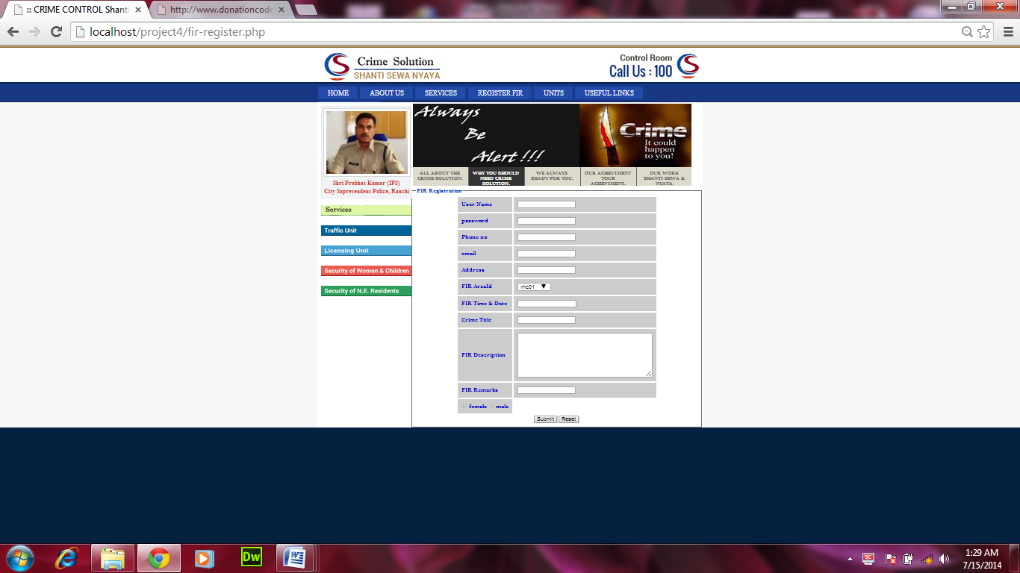

**Coding For FIR Registration**

<head>

<meta http-equiv="Content-Type" content="text/html; charset=utf-8" />

<title>:: CRIME CONTROL Shanti Sewa Nyaya ::</title>

<!--dropdown script start here-->

<script type="text/javascript" src="jquery.min.js"></script>

<script type="text/javascript" src="flexdropdown.js"></script>

<link rel="stylesheet" type="text/css" href="flexdropdown.css">

<link rel="stylesheet" type="text/css" href="general.css">

<link rel="stylesheet" type="text/css" href="style.css" />

<link href="layout.css" rel="stylesheet" type="text/css" />

<link href="featured_slide.css" rel="stylesheet" type="text/css" />

<script type="text/javascript" src="jquery-1.4.1.min.js"></script>

<script type="text/javascript" src="jquery-ui-1.7.2.custom.min.js"></script>

<script type="text/javascript" src="jquery.tabs.setup.js"></script>

<!--dropdown script start here-->

<?php

$err="";

$err1="";

$err2="";

$err3="";

$err4="";

$err5="";

$err6="";

$err7="";

$err8="";

$err9="";

if($_SERVER["REQUEST_METHOD"]=="POST")

{

if($_POST["t1"]=="")

{

$err="* name require";

}

if($_POST["t2"]=="")

{

$err1="* phone no. require";

}

if($_POST["t3"]=="")

{

$err2="* email require";

}

if($_POST["t4"]=="")

{

$err3="* address require";

}

if($_POST["t5"]=="")

{

$err4="* date & time require";

}

if($_POST["t6"]=="")

{

$err5="* crime title require";

}

else

{

$nm=$_POST["t1"];

$pa=$_POST["t11"];

$ph=$_POST["t2"];

$em=$_POST["t3"];

$add=$_POST["t4"];

$ar_id=$_POST["s1"];

$dat=$_POST["t5"];

$titl=$_POST["t6"];

$des=$_POST["description"];

$rmrk=$_POST["t8"];

$gndr=$_POST["gender"];

$con=@mysql_connect("localhost","root","");

if(!$con)

{

echo "connection failed";

}

mysql_select_db("project");

$qry="insert into firregister (name,password,phone,email,address,area_id,time_date,crime_title,fir_description,fir_remark,gender) values('$nm','$pa','$ph','$em','$add','$ar_id','$dat','$titl','$des','$rmrk','$gndr')";

mysql_query($qry);

if(mysql_affected_rows()>0)

{

header("location:get-register.php");

}

}

}

?>

</head>

<body>

<div class="top-boredr"></div>

<div class="header-main">

<div class="headers">

<div class="header">

<div class="logo1"><a href="#"><img src="image/logo1.png" alt="" width="326" height="87" border="0"></a><a href="#"></a>

</div>

<div class="lef-top-icon-logo"><img src="image/logo2.png" width="254" height="76" alt=""></div>

</div>

</div>

</div>

<div class="button-main">

<div class="btn">

<ul>

<li><a href="index1.php">HOME</a></li>

<li><a href="#" data-flexmenu="flexmenu1" stylez="position:relative;left:900px;top:200px">ABOUT US</a></li>

<li><a href="#" data-flexmenu="flexmenu2" stylez="position:relative;left:900px;top:200px">SERVICES</a><span class="btn-line"></span></li>

<li><a href="#" data-flexmenu="flexmenu3" stylez="position:relative;left:900px;top:200px" class="">REGISTER FIR</a></li>

<li><a href="#" data-flexmenu="flexmenu4" stylez="position:relative;left:900px;top:200px" class="">UNITS</a></li>

<li><a href="#" data-flexmenu="flexmenu5" stylez="position:relative;left:900px;top:200px" class="">USEFUL LINKS</a></li>

<li><a href="#" data-flexmenu="flexmenu6" stylez="position:relative;left:900px;top:200px">CONTACT US</a></li>

</ul>

<ul id="flexmenu1" class="flexdropdownmenu jqflexmenu" style="display: none; visibility: visible; z-index: 1000;">

<li><a href="history-police.php">History</a></li>

<li><a href="citizen-charter.php">Citizens' Charter</a></li>

<li><a href="#">Former Commissioners</a></li>

<li><a href="medals.php">Medals</a></li>

<li><a href="#">Appreciation letters from public</a></li>

</ul>

<ul id="flexmenu2" class="flexdropdownmenu jqflexmenu" style="display: none; visibility: visible; z-index: 1000;">

<li><a href="#">Missing Persons</a></li>

<li><a href="senior citizen.php">Senior Citizens Registration</a></li>

<li><a href="passport.php">Guidelines / Information in c/w passport verification and registration of Pakistan National</a></li>

<li><a href="#">Downloadable Forms</a></li>

<li><a href="mess-acco.php">Go's Mess Accommodation &amp; Tariff</a></li>

</ul>

<ul id="flexmenu3" class="flexdropdownmenu jqflexmenu" style="visibility: visible; z-index: 1003; left: 534px; top: 152px; display: none;">

<li><a href="fir-register.php">Registration-form</a></li>

</ul><ul id="flexmenu4" class="flexdropdownmenu jqflexmenu" style="visibility: visible; z-index: 1002; left: 684px; top: 152px; display: none;">

<li><a href="#">Recruitment Cell</a></li>

<li><a href="mounted-police.php">Mounted Police</a></li>

</ul>

<ul id="flexmenu5" class="flexdropdownmenu jqflexmenu" style="visibility: visible; z-index: 1001; left: 788px; top: 152px; display: none;">

<li><a href="#">waht is section 144</a></li>

<li><a href="#">Help Lines</a></li>

<li><a href="about fund.php">About Funds</a></li>

<li><a href="notification1.html">Notification</a></li>

</ul>

<ul id="flexmenu6" class="flexdropdownmenu jqflexmenu" style="display: none; visibility: visible; z-index: 1000;">

<li><a href="#">E-mail Us</a></li>

<li><a href="telephone_directory.php">Telephone Directory</a></li>

</ul>

</div>

</div>

<div class="center-page-main">

<div class="wraper">

<div class="main">

<div class="left-side-page-index">

<div class="img-main-in1">

<div class="img1-1">

<div class="imgage">

<a href="#" target="_blank"><img src="image/SP-ranchi.jpeg" alt="" width="218" height="168" border="0"></a>

</div>

</div>

<div class="text-im1">Shri Prabhat Kumar (IPS)<br>

City Supretendent Police, Ranchi

</div>

</div>

<div></div><br>

<table width="100%" border="0" cellspacing="0" cellpadding="0" style="float:left; clear:both;">

<tbody><tr>

<td height="17"></td>

</tr>

<tr>

<td><a href="service.php"><img src="image/rti-manual.jpg" width="242" height="29" alt=""></a></td>

</tr>

<tr>

<td height="10"></td>

</tr>

<tr><td>&nbsp;</td></tr>

<tr>

<td><a href="traffic.php"><img src="image/traffic-unit.jpg" width="242" height="29" alt=""></a></td>

</tr>

<tr>

<td height="10"></td>

</tr>

<tr><td>&nbsp;</td></tr>

<tr>

<td><a href="licencing.php"><img src="image/licensing-unit.jpg" width="242" height="29" alt=""></a></td>

</tr>

<tr>

<td height="10"></td>

</tr>

<tr><td>&nbsp;</td></tr>

<tr>

<td><a href="security_of_women_children.php"><img src="image/women-helpline-tab.jpg" width="242" height="29" alt=""></a></td>

</tr>

<tr>

<td height="10"></td>

</tr>

<tr>

<td>&nbsp;</td>

</tr>

<tr>

<td><a href="ne-resident.php"><img src="image/security-of-ne-res.jpg" width="242" height="29" alt=""></a></td>

</tr>

</tbody></table>

</div>

<div id="featured_slide" class="clear">

<!-- ###### -->

<div class="overlay_left"></div>

<div id="featured_content">

<div class="featured_box" id="fc1"><img src="image/slid1.jpg" alt="" />

</div>

<div class="featured_box" id="fc2"><img src="image/slid2.jpg" alt="" />

</div>

<div class="featured_box" id="fc3"><img src="image/slid3.jpg" alt="" />

</div>

<div class="featured_box" id="fc4"><img src="image/slid4.jpg" alt="" />

</div>

<div class="featured_box" id="fc5"><img src="image/slid5.jpg" alt="" />

</div>

</div>

<ul id="featured_tabs">

<li><a href="#fc1">All About The Crime Solution.</a></li>

<li><a href="#fc2">Why You Should need Crime Solution.</a></li>

<li><a href="#fc3">We Always ready for you.</a></li>

<li><a href="#fc4">Our Acheviment Your Acheviment.</a></li>

<li class="last"><a href="#fc5">Our Work Shanti Sewa &amp; Nyaya</a></li>

</ul>

<!-- ###### -->

</div>

<form id="f1" name="f1" action="<?php echo $_SERVER['PHP_SELF'];?>" method="post">

<fieldset>

<legend style="color:#03C; font-weight:bolder;">FIR Registration</legend>

<center>

<table cellpadding="10" cellspacing="4">

<tbody bgcolor="#CCCCCC">

<tr>

<td style="font-weight:bolder;"><font color="#0000CC">User Name</font></td>

<td><input type="text" id="t1" name="t1" />

<span class="error"><?php echo $err;?></span>

</td>

</tr>

<tr>

<td style="font-weight:bolder;"><font color="#0000CC">password</font></td>

<td><input type="password" id="t11" name="t11"></td>

</tr>

<tr>

<td style="font-weight:bolder;"><font color="#0000CC">Phone no</font></td>

<td><input type="text" id="t2" name="t2" />

<span class="error"><?php echo $err1;?></span>

</td>

</tr>

<tr>

<td style="font-weight:bolder;"><font color="#0000CC">email</font></td>

<td><input type="email" id="t3" name="t3" />

<span class="error"><?php echo $err2;?></span>

</td>

</tr>

<tr>

<td style="font-weight:bolder;"><font color="#0000CC">Address</font></td>

<td><input type="text" id="t4" name="t4" />

<span class="error"><?php echo $err3;?></span>

</td>

</tr>

<tr>

<td style="font-weight:bolder;"><font color="#0000CC">FIR AreaId</font></td>

<td><select name="s1" id="s1">

<option>rnc01</option>

<option>rnc02</option>

<option>rnc03</option>

<option>rnc04</option>

<option>rnc05</option>

<option>rnc07</option>

<option>rnc08</option>

<option>rnc09</option>

<option>rnc10</option>

<option>rnc11</option>

</select>

<span class="error"><?php echo $err4;?></span>

</td>

</tr>

<tr>

<td style="font-weight:bolder;"><font color="#0000CC">FIR Time & Date</font></td>

<td><input type="datetime" id="t5" name="t5" />

<span class="error"><?php echo $err5;?></span>

</td>

</tr>

<tr>

<td style="font-weight:bolder;"><font color="#0000CC">Crime Title</font></td>

<td><input type="text" id="t6" name="t6" />

<span class="error"><?php echo $err6;?></span>

</td>

</tr>

<tr>

<td style="font-weight:bolder;"><font color="#0000CC">FIR Description</font></td>

<td><textarea name="description" rows="7" cols="40" id="t7"></textarea>

<span class="error"><?php echo $err7;?></span>

</td>

</tr>

<tr>

<td style="font-weight:bolder;"><font color="#0000CC">FIR Remarks</font></td>

<td><input type="text" id="t8" name="t8" />

<span class="error"><?php echo $err8;?></span>

</td>

</tr>

<tr>

<td style="font-weight:bolder;"><font color="#0000CC">

<input type="radio" name="gender" value="female" id="t9">female

<input type="radio" name="gender" value="male" id="t9">male

</font>

<span class="error"><?php echo $err9;?></span>

</td>

</tr>

</tbody>

</table>

</center>

<center>

<table>

<tbody bgcolor="#CCCCCC">

<tr>

<td><input type="submit" id="s11" name="s11">

</td>

<td><input type="reset" id="reset" name="reset">

</td>

</tr>

</tbody>

</table>

</center>

</fieldset>

</form>

</body>

</html>

**Coding for view fir**

<table width="100%" border="0" cellspacing="0" cellpadding="0">

<tbody><tr>

<td><table width="100%" border="0" cellspacing="0" cellpadding="0">

<tbody><tr>

<td align="center" valign="top"><table border="0" cellspacing="0" cellpadding="0">

<tbody><tr>

<td>

<form id="f1" name="f1" method="post" action="view-conn.php">

<table cellpadding="4" cellspacing="10">

<tr>

<td>View F.I.R by</td><td><select name="s1" id="s1">

<option value="0">select</option>

<option value="1">area_id</option>

<option value="2">fir_id</option>

</select>

</td>

</tr>

<tr>

<td>enter key</td>

<td><input type="text" name="t1" id="t1"></td>

</tr>

<tr>

<td colspan="2">

<input type="submit" id="s11" name="s11">

</td>

</tr>

</table>

</form>

**View-connection**

<?php

$conn=@mysql_connect("localhost","root","");

if(!$conn)

{

echo"connection failed...";

}

mysql_select_db("project");

$op=$_REQUEST['s1'];

$n=$_REQUEST['t1'];

if($op==1)

{

$qry="select * from firregister where area_id='$n'";

}

else

{

$qry="select * from firregister where fir_id='$n'";

}

$smt=mysql_query($qry);

?>

<table border="2">

<tr>

<th>FIR_id</th>

<th>Name</th>

<th>Phone no.</th>

<th>E_mail</th>

<th>Address</th>

<th>Area_id</th>

<th>Time & Date</th>

<th>Crime_Title</th>

<th>FIR_description</th>

<th>FIR_remark</th>

<th>Gender</th>

</tr>

<?php

while(($rs=mysql_fetch_assoc($smt)))

{

echo"<tr>";

echo"<td>".$rs['fir_id']."</td>";

echo"<td>".$rs['name']."</td>";

echo"<td>".$rs['phone']."</td>";

echo"<td>".$rs['email']."</td>";

echo"<td>".$rs['address']."</td>";

echo"<td>".$rs['area_id']."</td>";

echo"<td>".$rs['time_date']."</td>";

echo"<td>".$rs['Crime_Title']."</td>";

echo"<td>".$rs['fir_description']."</td>";

echo"<td>".$rs['fir_remark']."</td>";

echo"<td>".$rs['gender']."</td>";

echo"<tr>";

}

?>

</table>

MISSING PERSON

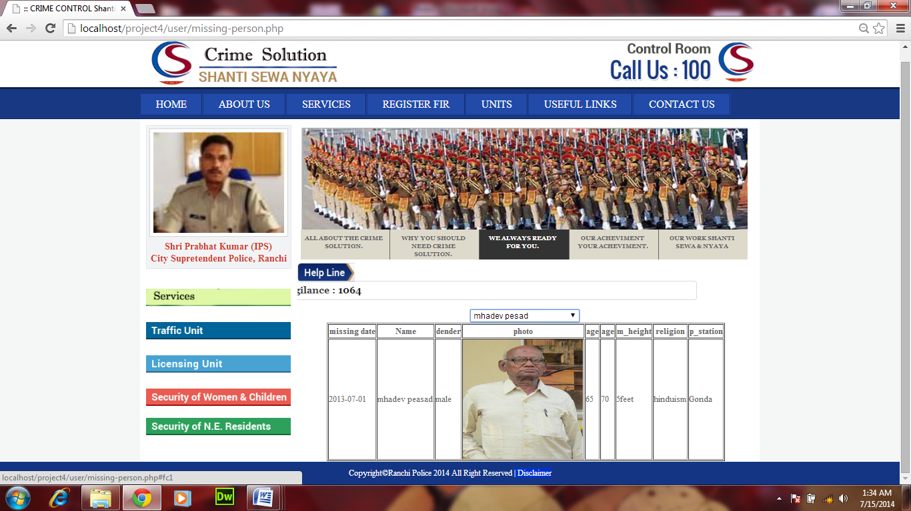

**Coding for insert missing person**

<div style="min-height:314px;" class="text-cont">

<!-- <img style="padding-left:10px; width:220px; height:176px; float:right;" src="images/cp.jpg"/> -->

<fieldset class="tabul1">

<legend style="font-weight:bolder; font-size:18px; color:#33F;">Missing Person

</legend>

<form id="f1" name="f1" method="post" action="missing-person-action.php">

<table align="center">

<tr>

<td>Missing Date:</td>

<td><input type="date" id="t" name="t" /></td>

</tr>

<tr>

<td>Name :</td>

<td><input type="text" id="t1" name="t1" /></td>

</tr>

<tr>

<td>Gender :</td>

<td><input type="radio" name="gender" value="female" />female</td>

<td><input type="radio" name="gender" value="male" />male</td>

</tr>

<tr>

<td>Photo :</td>

<td><input type="file" name="t2" id="t2" /></td>

</tr>

<tr>

<td>Age range from:</td>

<td><input type="text" name="t3" id="t3" /></td>

<td>End:</td>

<td><input type="text" name="t4" id="t4" /></td>

</tr>

<tr>

<td>Height(feet & Inches)/cms:</td>

<td><input type="text" name="t5" id="t5" /></td>

</tr>

<tr>

<td>Religion</td>

<td><select id="t6" name="t6">

<option>--select--</option>

<option>hinduism</option>

<option>chirstian</option>

<option>buddhist</option>

<option>jain</option>

<option> muslim</option>

</select>

</td>

</tr>

<tr>

<td>Police Station</td>

<td><select id="t7" name="t7">

<option>--select--</option>

<option>Kotwali</option>

<option>Sadar</option>

<option>Sukhdev Nagar</option>

<option>Gonda</option>

<option>Hindipiri</option>

<option>Kanke</option>

<option>Bariatu</option>

<option>Doronda</option>

<option>Dhurwa</option>

<option>Jaganathpur</option>

<option>Argora</option>

</select>

</td>

</tr>

</table>

<table align="center">

<tr>

<td class="tabul"><input type="submit" value="submit" style="font-weight:bolder;" /></td>

<td>&nbsp;&nbsp;</td>

<td class="tabul"><input type="reset" value="reset" style="font-weight:bolder;" /></td>

</tr>

</table>

</form>

</fieldset>

</div>

**Action page for missing person**

<div style="min-height:314px;" class="text-cont">

<!-- <img style="padding-left:10px; width:220px; height:176px; float:right;" src="images/cp.jpg"/> -->

<!--Connectivity--------------->

<?php

$conn=@mysql_connect("localhost","root","");

if(!$conn)

{

echo "connection failed...";

}

mysql_select_db("project");

$md=$_REQUEST['t'];

$nm=$_REQUEST['t1'];

$gn=$_REQUEST['gender'];

$ph=$_REQUEST['t2'];

$as=$_REQUEST['t3'];

$ae=$_REQUEST['t4'];

$ht=$_REQUEST['t5'];

$rn=$_REQUEST['t6'];

$ps=$_REQUEST['t7'];

$qry="insert into missing_person(miss_date,name,gender,photo,age_s,age_e,

m_height,religion,p_station)values('$md','$nm','$gn','$ph','$as','$ae','$ht',

'$rn','$ps')";

mysql_query("$qry");

if(mysql_affected_rows()>0)

{

echo"your complain has been accepted<p>try to quick action... ";

}

else

{

echo"error";

}

?>

</div>

**Coding For Searching missing person using AJAX**

<head>

<script>

function showUser(str) {

if (str=="") {

document.getElementById("txtHint").innerHTML="";

return;

}

if (window.XMLHttpRequest) {

xmlhttp=new XMLHttpRequest();

} else {

xmlhttp=new ActiveXObject("Microsoft.XMLHTTP");

}

xmlhttp.onreadystatechange=function() {

if (xmlhttp.readyState==4 && xmlhttp.status==200) {

document.getElementById("txtHint").innerHTML=xmlhttp.responseText;

}

}

xmlhttp.open("GET","criminal-action.php?q="+str,true);

xmlhttp.send();

}

</script>

</head>

<table width="100%" border="0" cellspacing="0" cellpadding="0">

<tbody><tr>

<td><table width="100%" border="0" cellspacing="0" cellpadding="0">

<tbody><tr>

<td align="center" valign="top"><table border="0" cellspacing="0" cellpadding="0">

<tbody><tr>

<td>

<form>

<select name="users" onChange="showUser(this.value)">

<option value="">Select a criminal name:</option>

<option value="6">surendra gupta</option>

<option value="7">vinesh binesh</option>

<option value="8">Ramnek yadav</option>

<option value="9">Ramnek peela</option>

<option value="10">surendra binesh</option>

</select>

</form>

<br>

<div id="txtHint"><b>your information</b></div>

</td>

CRIMINAL PAGE

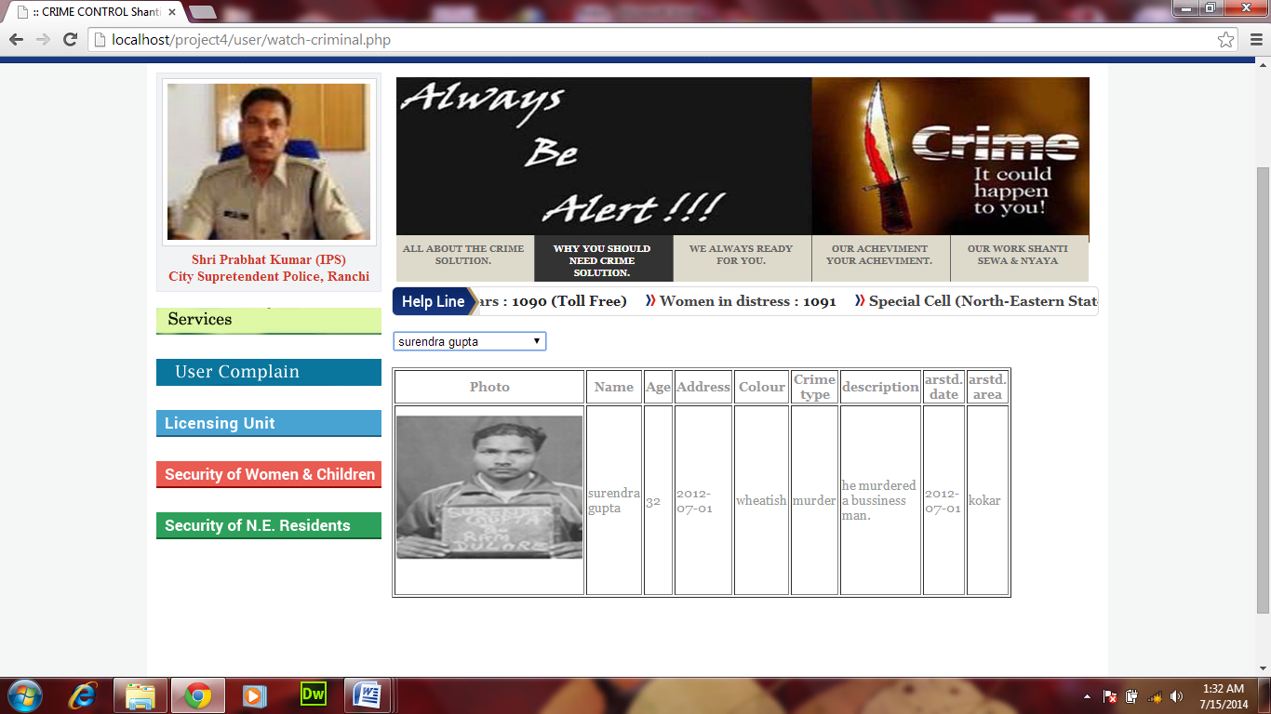

**Criminal action**

<body>

<?php

$q = intval($_GET['q']);

$con = mysqli_connect('localhost','root','','project');

if (!$con) {

die('Could not connect: ' . mysqli_error($con));

}

mysqli_select_db($con,"project");

$sql="SELECT * FROM criminal WHERE sl_no = '".$q."'";

$result = mysqli_query($con,$sql);

echo "<table border='1'>

<tr>

<th>Photo</th>

<th>Name</th>

<th>Age</th>

<th>Address</th>

<th>Colour</th>

<th>Crime type</th>

<th>description</th>

<th>arstd. date</th>

<th>arstd. area</th>

</tr>";

while($row = mysqli_fetch_array($result)) {

echo "<tr>";

echo "<td>" .'<img height="200" width="200" src="../admin/image1//'. $row['photo'] .'">'."</td>";

echo "<td>" . $row['c_name'] . "</td>";

echo "<td>" . $row['age'] . "</td>";

echo "<td>" . $row['adress'] . "</td>";

echo "<td>" . $row['color'] . "</td>";

echo "<td>" . $row['crime_type'] . "</td>";

echo "<td>" . $row['description'] . "</td>";

echo "<td>" . $row['a_date'] . "</td>";

echo "<td>" . $row['a_area'] . "</td>";

echo "</tr>";

}

echo "</table>";

mysqli_close($con);

?>

</body>

</html>

**User complain**

<div style="min-height:314px;" class="text-cont">

<!-- <img style="padding-left:10px; width:220px; height:176px; float:right;" src="images/cp.jpg"/> -->

<fieldset class="tabul1">

<legend style="font-weight:bolder; font-size:18px; color:#33F;">Complain Form</legend>

<table align="center">

<form id="f1" name="f1" method="post" action="user-complain-action.php">

<tr>

<td><font color="#000000">F.I.R. id:</font></td>

<td><input type="text" id="t" name="t" /></td>

</tr>

<tr>

<td><font color="#000000">Name:</font></td>

<td><input type="text" id="t1" name="t1" size="65px;"/></td>

</tr>

<tr>

<td><font color="#000000">Address:</font></td>

<td><textarea rows="3" cols="50" name="t2" style="resize:none;"></textarea></td>

</tr>

<tr>

<td><font color="#000000">Contact No.:</font></td>

<td><input type="number" id="t3" name="t3"/></td>

</tr>

<tr>

<td><font color="#000000">Complain:</font></td>

<td><textarea rows="10" cols="50" name="t4" style="resize:none;"></textarea></td>

</tr>

</table>

<table align="center">

<tr>

<td class="tabul"><input type="submit" value="submit" style="font-weight:bolder;" /></td>

<td>&nbsp;&nbsp;</td>

<td class="tabul"><input type="reset" value="reset" style="font-weight:bolder;" /></td>

</tr>

</table>

</form>

</fieldset>

</div>

**User Complain Action Page**

<div class="clr"></div>

<div style="min-height:314px;" class="text-cont">

<!-- <img style="padding-left:10px; width:220px; height:176px; float:right;" src="images/cp.jpg"/> -->

<!--Connectivity--------------->

<?php

$conn=@mysql_connect("localhost","root","");

if(!$conn)

{

echo "connection failed...";

}

mysql_select_db("project");

$fi=$_REQUEST['t'];

$nm=$_REQUEST['t1'];

$ad=$_REQUEST['t2'];

$pn=$_REQUEST['t3'];

$cm=$_REQUEST['t4'];

$qry="insert into complain(fir_id,name,address,phn_number,complain)

values($fi,'$nm','$ad','$pn','$cm')";

mysql_query("$qry");

if(mysql_affected_rows()>0)

{

echo"your complain has been accepted<p>try to quick action... ";

}

?>

</div>

**Senior Citizen**

<form id="f1" name="f1" method="post" action="senior citizen-conn.php">

<table rules="none" align="center" width="750px" border="1">

<tbody>

<tr><td></td></tr>

<tr>

<td height="200px">

<fieldset>

<legend style="font-weight:bolder;"><font face="Verdana, Geneva, sans-serif"><font color="#000000">Personal Details

</font></font> </legend>

<table>

<tr>

<td style="color:#33F;">Name:</td>

<td><input type="text" id="t1" name="t1" /></td>

<td width="22%"></td>

<td style="color:#33F;">D.O.B.</td>

<td><input type="date" id="t2" name="t2" /></td>

</tr>

<tr>

<td style="color:#33F;">Age:</td>

<td><input type="text" id="t3" name="t3" /></td>

<td width="22%"></td>

<td style="color:#33F;">Address:</td>

<td><input type="text" id="t4" name="t4" /></td>

</tr>

<tr>

<td style="color:#33F;">Gender:</td>

<td><select id="t5" name="t5">

<option value="">--select--</option>

<option value="male">male</option>

<option value="female">female</option>

</select>

</td>

<td width="22%"></td>

<td style="color:#33F;">Religion</td>

<td><select id="t6" name="t6">

<option value="">--select--</option>

<option value="R001">hinduism</option>

<option value="R002">chirstian</option>

<option value="R003">buddhist</option>

<option value="R004">jain</option>

<option value="R005"> muslim</option>

</select>

</td>

</tr>

<tr>

<td style="color:#33F;">Tel. No.:</td>

<td><input type="text" id="t7" name="t7" /></td>

<td width="22%"></td>

<td style="color:#33F;">Mobile No.:</td>

<td><input type="text" id="t8" name="t8" /></td>

</tr>

<tr>

<td style="color:#33F;">District</td>

<td><select id="t9" name="t9">

<option value="">--select--</option>

<option value="d1">Ranchi</option>

</select>

</td>

<td width="22%"></td>

<td style="color:#33F;">Police Station</td>

<td><select id="t10" name="t10">

<option value="">--select--</option>

<option value="1">Ranchi</option>

<option value="2">Ranchi</option>

<option value="3">Ranchi</option>

<option value="4">Ranchi</option>

<option value="5">Ranchi</option>

<option value="6">Ranchi</option>

<option value="7">Ranchi</option>

<option value="8">Ranchi</option>

<option value="9">Ranchi</option>

<option value="10">Ranchi</option>

<option value="11">Ranchi</option>

</select>

</td>

</tr>

<tr>

<td style="color:#33F;">Email</td>

<td><input type="email" id="t11" name="t11" /></td>

<td width="22%"></td>

<td style="color:#33F;">Year of Retairmrnt</td>

<td><select id="t12" name="t12">

<option value="">-select-</option>

<option value="y01">1994</option>

<option value="y02">1995</option>

<option value="y03">1996</option>

<option value="y04">1997</option>

<option value="y05">1998</option>

<option value="y06">1999</option>

<option value="y07">2000</option>

<option value="y08">2001</option>

<option value="y09">2002</option>

<option value="y10">2003</option>

<option value="y11">2004</option>

<option value="y12">2005</option>

<option value="y13">2006</option>

<option value="y14">2007</option>

<option value="y15">2008</option>

<option value="y16">2009</option>

<option value="y17">2010</option>

<option value="y18">2011</option>

<option value="y19">2012</option>

<option value="y20">2013</option>

<option value="y21">2014</option>

</select>

</td>

</tr>

</table>

</fieldset>

<fieldset>

<legend style="color:#000; font-weight:bolder;" ><font face="Verdana, Geneva, sans-serif">Other Details</legend>

<table>

<tr>

<td style="color:#33F;">No. of children</td>

<td><select id="t13" name="t13">

<option> 0</option>

<option>1</option>

<option>2</option>

<option>3</option>

<option>4</option>

<option>5</option>

<option>6</option>

<option>7</option>

<option>8</option>

<option>9</option>

<option>10</option>

</select>

</td>

<td width="22%"></td>

<td style="color:#33F;">Family</td>

<td><select id="t14" name="t14">

<option value="joint">joint</option>

<option value="nuclear">nuclear</option>

<option value="single">single</option>

</select>

</td>

</tr>

<tr>

<td style="color:#33F;">Health</td>

<td><select id="t15" name="t15">

<option value="vg">very good</option>

<option value="p">poor</option>

<option value="g">good</option>

<option value="e">excellent</option>

</select>

</td>

<td width="22%"></td>

<td style="color:#33F;">Residing With</td>

<td>

<select id="t16" name="t16">

<option value="1">Alone</option>

<option value="2">Children</option>

<option value="3">friends/relatives</option>

</select>

</td>

</tr>

</table>

</fieldset>

<fieldset>

<legend style="color:#000; font-weight:bolder;"><font face="Verdana, Geneva, sans-serif">Relative Details

</legend>

<table>

<tr>

<td style="color:#33F;">Relative's Name</td>

<td><input type="text" id="t17" name="t17" /></td>

<td width="22%"></td>

<td style="color:#33F;">Relation</td>

<td>

<select id="t18" name="t18">

<option value="R1">Aunty</option>

<option value="R2">Brother</option>

<option value="R3">Brother-In-Law</option>

<option value="R4">cousin</option>

<option value="R5">Daughter</option>

<option value="R6">Daughter-In-Law</option>

<option value="R7">Father</option>

<option value="R8">Father-In-Law</option>

<option value="R9">Son</option>

</select>

</td>

</tr>

<tr>

<td style="color:#33F;">Address</td>

<td><input type="text" id="t19" name="t19" /></td>

<td width="22%"></td>

<td style="color:#33F;">Tel.No.</td>

<td><input type="text" id="t20" name="t20" /></td>

</tr>

</table>

</fieldset>

<fieldset>

<legend style="color:#000; font-weight:bolder;"><font face="Verdana, Geneva, sans-serif">Servent</font></legend>

<table>

<tr>

<td width="150px"><input type="radio" name="t21" value="ft" />

<font color="#3333FF";>full time</font></td>

<td width="171px"><input type="radio" name="t21" value="pt" />

<font color="#3333FF";>part time</font></td>

<td width="201px"><input type="radio" name="t21" value="None" />

<font color="#3333FF";>none</font></td>

</tr>

</table>

</fieldset>

<fieldset>

<legend style="color:#000; font-weight:bolder;"><font face="Verdana, Geneva, sans-serif">Driver</legend>

<table>

<tr>

<td width="150px"><input type="radio" name="t22" value="dft" />

<font color="#3333FF";>full time</font></td>

<td width="171px"><input type="radio" name="t22" value="dpt" />

<font color="#3333FF";>part time</font></td>

<td width="201px"><input type="radio" name="t22" value="dn" />

<font color="#3333FF";>None</font></td>

</tr>

</table>

</fieldset>

<fieldset>

<legend style="color:#000; font-weight:bolder;"><font face="Verdana, Geneva, sans-serif">Watchman</font>

</legend>

<table>

<tr>

<td width="150px"><input type="radio" name="t23" value="wft" />

<font color="#3333FF";>full time</font></td>

<td width="171px"><input type="radio" name="t23" value="wpt" />

<font color="#3333FF";>part time</font></td>

<td width="201px"><input type="radio" name="t23" value="wn" />

<font color="#3333FF">None</font>

</td>

</tr>

</table>

</fieldset>

<fieldset>

<legend style="color:#000; font-weight:bolder;"><font face="Verdana, Geneva, sans-serif">Tenant</legend>

<table>

<tr>

<td width="150px"><input type="radio" name="t24" value="single" />

<font color="#3333FF";>single</font></td>

<td width="171px"><input type="radio" name="t24" value="family" />

<font color="#3333FF";>family</font></td>

<td width="201px"><input type="radio" name="t24" value="none" />

<font color="#3333FF">None</font>

</td>

</tr>

</table>

</fieldset>

<table align="center">

<tr>

<td class="tabul" style="color:#000; font-weight:bolder;"><input type="submit" value="submit" /></td>

<td width="15%"></td>

<td class="tabul" style="color:#000; font-weight:bolder;"><input type="reset" value="reset" /></td>

</tr>

</table>

</td></tr>

</table>

**Action Page for senior citizen**

<?php

$conn=@mysql_connect("localhost","root","");

if(!$conn)

{

echo "connection failed...";

}

mysql_select_db("project");

$nm=$_REQUEST['t1'];

$db=$_REQUEST['t2'];

$ag=$_REQUEST['t3'];

$add=$_REQUEST['t4'];

$gn=$_REQUEST['t5'];

$re=$_REQUEST['t6'];

$tn=$_REQUEST['t7'];

$mb=$_REQUEST['t8'];

$dist=$_REQUEST['t9'];

$ps=$_REQUEST['t10'];

$em=$_REQUEST['t11'];

$yor=$_REQUEST['t12'];

$noc=$_REQUEST['t13'];

$fmly=$_REQUEST['t14'];

$hlth=$_REQUEST['t15'];

$rw=$_REQUEST['t16'];

$rnm=$_REQUEST['t17'];

$r=$_REQUEST['t18'];

$radd=$_REQUEST['t19'];

$rtm=$_REQUEST['t20'];

$ser=$_REQUEST['t21'];

$dri=$_REQUEST['t22'];

$wtm=$_REQUEST['t23'];

$tnt=$_REQUEST['t24'];

$qry="insert into senior_citizen(name,d_o_b,age,address,gender,religion,tel_no,mb_no,dist,p_station,email,y_o_retair,no_of_child,family,health,residing,rel_name,relation,r_address,r_tel_no,servent,driver,watchman,tenant)

values('$nm','$db',$ag,'$add','$gn','$re','$tn','$mb','$dist','$ps','$em','$yor','$noc','$fmly','$hlth','$rw','$rnm','$r','$radd','$rtm','$ser','$dri','$wtm','$tnt')";

mysql_query("$qry");

if(mysql_affected_rows()>0)

{

header("location:get-registration-senior.php");

}

else

{

echo"no row inserted";

}

?>

**Testing**

Software testing determines the correctness, completeness and quality of software being developed. IEEE defines testing as “The process of exercising or evaluating a system or system component by manual or automated means to verify that it satisfies specified requirements or to identify differences between expected and actual results.”

Testing has the following levels:

* Unit Tesing.
* Integration testing.
* System Testing.
* Acceptanse Testing.

Unit Testing of the the project “**Online Crime Solution System**” is tested below:

**F.I.R. Register(any user)**

|  |  |  |  |
| --- | --- | --- | --- |
| **Sl. No.** | **Test Case** | **Expected Result** | **Test result** |
| 1 | Fill the FIR form & click submit button | s/w should display their fir id with successfully registered message. | Success |
| 2 | If any fieled is blank | s/w should indicate the fieled | Success |
| 3 | Admin registration | They get their membership for admin page | Success |

**Log in (registered user/admin):-**

|  |  |  |  |
| --- | --- | --- | --- |
| Sl.no. | Test Case | Expected Result | Test Result |
| 1 | Enter valid username & password &  Click ok button | s/w should display user/admin  page for further proccess | Success |
| 2 | Enter invalid | s/w should display invalid username &password | Success |

**Senior citizen entry:-**

|  |  |  |  |
| --- | --- | --- | --- |
| **Sl.no.** | **Test Case** | **Expected Result** | **Test Result** |
| 1 | Fill the form & click submit  button | s/w should display the message of successfully registration with regd. no. | Success |

**Traffic code :-**

|  |  |  |  |
| --- | --- | --- | --- |
| **Sl. No.** | **Test case** | **Expected result** | **Test result** |
| 1 | Fill the form & click submit button | s/w should display the challan no. | **Success** |

**Women Complain :-**

|  |  |  |  |
| --- | --- | --- | --- |
| **Sl. no** | **Test case** | **Expected result** | **Test result** |
| 1 | Fill the form & click submit button | Display message try to quick action | **Success** |

**Admin page**:-

|  |  |  |  |
| --- | --- | --- | --- |
| **Sl. no.** | **Test case** | **Expected result** | **Test result** |
| 1 | Update current status of user’s FIR | s/w should display successfully entry of database | Success |
| 2 | Add missing person & telephone no. | s/w should display successfully entry of database | Success |

**User page :-**

|  |  |  |  |
| --- | --- | --- | --- |
| **Sl. no.** | **Test case** | **Expected result** | **Test result** |
| 1 | Check current status | s/w should display their current status of FIR | Success |
| 2 | Watch missing person &telephone no. | s/w should display the information of missing person & imp. Telephone no. | Success |
| 3 | User complain | s/w should display the message try to quick action | Success |

LIMITATIONS

* It is not very big project for the online detail system
* It is not character based so to run it we need 32 or 64 bit windows operating system

**FEATURE OF PROJECT**

* User friendly
* Can run on internet/intranet so many clients can be handeled by this project so mit will save the time
* In future any modification can be done smoothly
* There is a section feed back which solves the problem of user actually it is visible to all client and can send the problem difficulty to administrator and admin has facility to read the all feed back according to feed back he can reply and improve the site ect……..

**BIBLIOGRAPHY**

* [www.w3school.com](http://www.w3school.com)
* www.google.co.in
* [www.wikipedia.com](http://www.wikipedia.com)
* [www.tutorial.com](http://www.tutorial.com)
* [www.csssliderwow.com](http://www.csssliderwow.com)
* FUNDAMENTAL OF DATABASE SYSTEM – KORTH
* SOFTWARE ENGEENERING – ROHIT KHURANA